Device Layer — Threat 1: Device Tampering
Overview and Context
Device tampering is a high-priority physical-layer threat in smart agriculture IoT. An adversary with direct access to the ESP32-S3 microcontroller manipulates the DHT22 temperature–humidity sensor or the capacitive soil moisture probe. This threat was simulated by:
- Heating the DHT22 (>80 °C) to spike sensor output.
- Disconnecting the DHT22 to induce NaN values.
- Removing or shorting the soil probe to produce abrupt, unrealistic values.
Without local validation, these readings were published to the cloud (esp32/data), corrupting dashboard and backend decisions.
MITRE ATT&CK Mapping
MITRE Domain | Tactic | Technique | Technique ID
Enterprise/ICS | Impact (Integrity Violation) | Data Manipulation | T1565
ICS Extension | Impact (Process Manipulation) | Manipulation of Control | T0831
This mapping shows both integrity compromise and operational impact, confirming the relevance to MITRE's frameworks.
CVSS v3.1 Assessment
Metric | Value | Rationale
AV | P | Requires direct physical access
AC | L | Easily executable
PR | N | No privileges/auth required
UI | N | Autonomous post-manipulation
S | U | Attack confined to device/system
C | L | Minimal confidentiality exposure
I | H | High impact on integrity (decisions/data)
A | L | Minimal loss in availability
Vector: CVSS:3.1/AV:P/AC:L/PR:N/UI:N/S:U/C:L/I:H/A:L
Base Score: 7.0 (High)
Despite needing physical proximity, the ease and crop impact justify a high CVSS score (Meneghello et al., 2019; Oche et al., 2021).
Before Mitigation (Evidence)
With insecure firmware, ESP32 published readings without any checks:
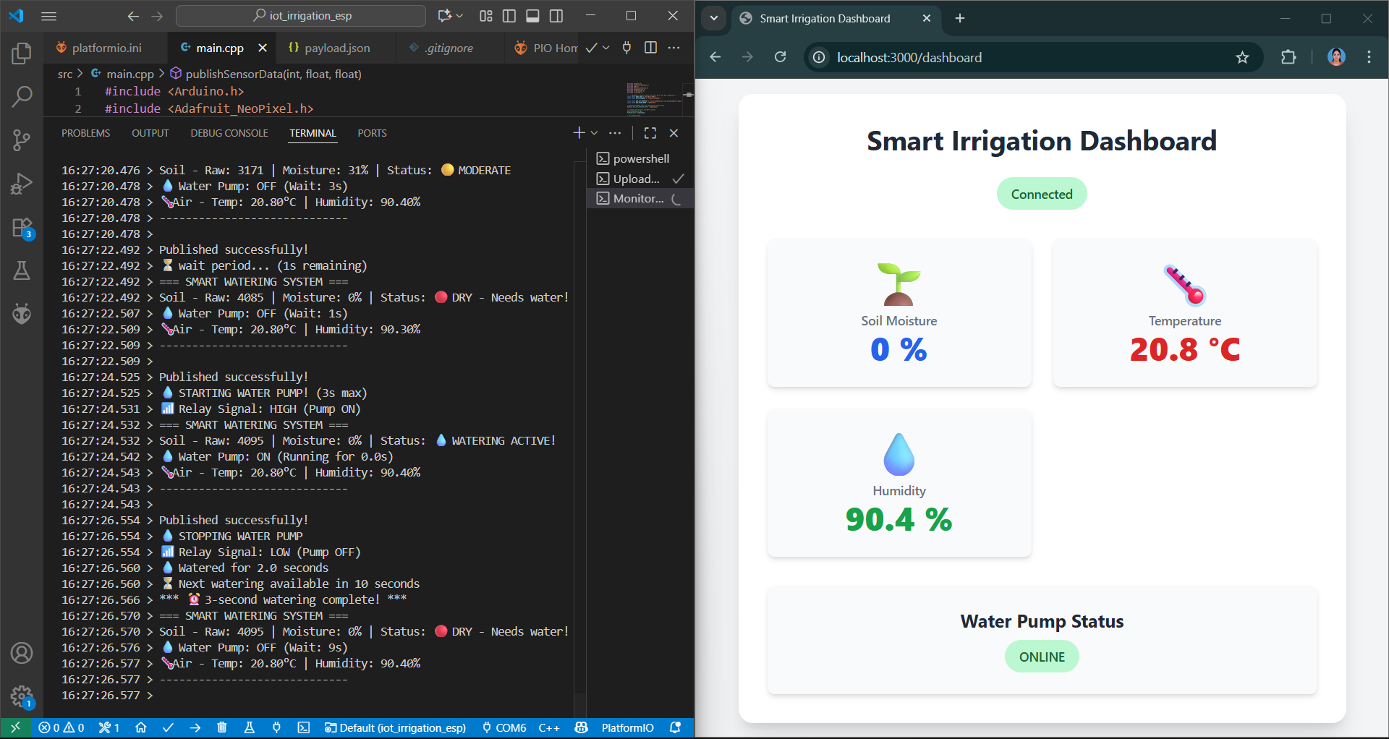
Figure 1: Remove the moisture sensor from the plant shows as the result - 0
- Probe unplugged, Soil Moisture 0% in terminal/dashboard.
- AWS IoT Core/DynamoDB accepted invalid values, leading to erroneous farm decisions.
After Mitigation (Secure Firmware with Onboard Validation)
Firmware was enhanced with validateSensorData() for sensor value and tamper detection:
bool validateSensorData(int& moisture, float& temp, float& hum) {
if (isnan(temp) || temp < MIN_TEMPERATURE_C || temp > MAX_TEMPERATURE_C) {
publishLog(\"ALERT\", \"Temperature out of range or NaN.\");
temp = last_valid_temperature;
return false;}
if (moisture < MIN_MOISTURE_PERCENT || moisture > MAX_MOISTURE_PERCENT) {
publishLog(\"ALERT\", \"Moisture out of range.\");
moisture = last_valid_moisture;
return false;}"
return true;}"
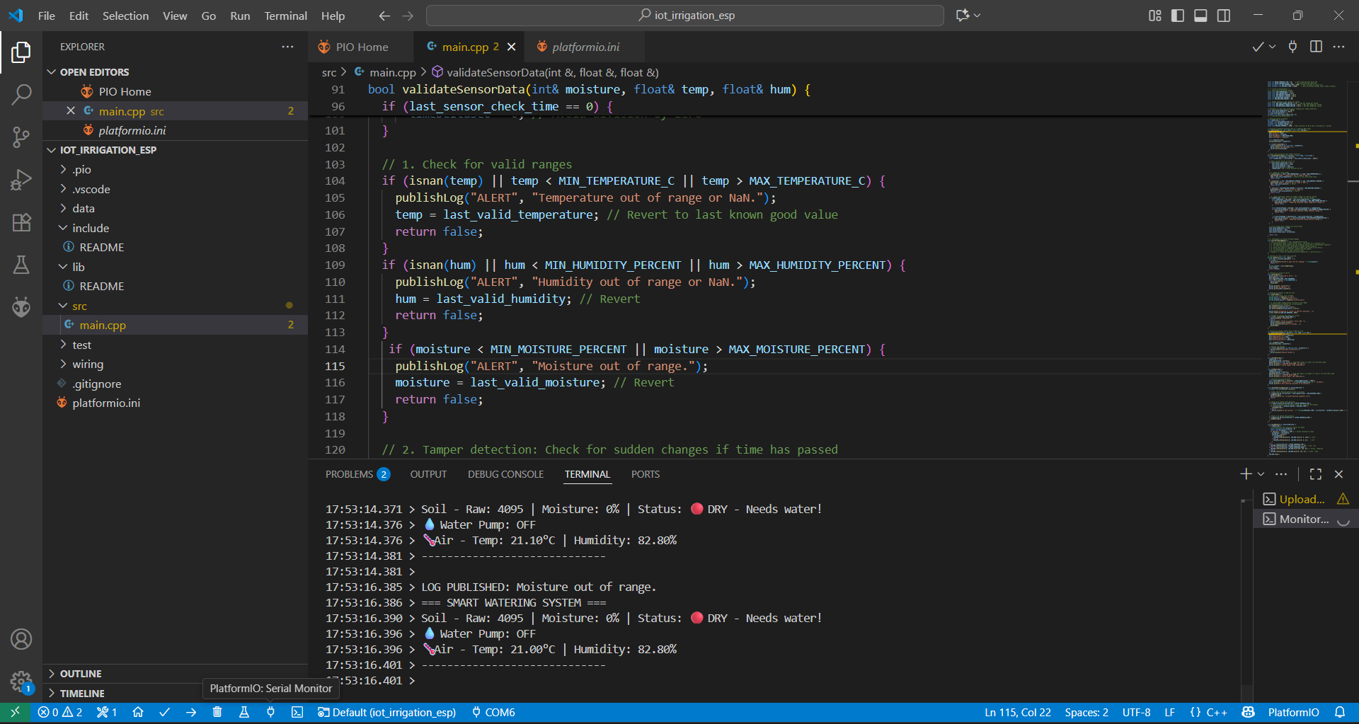
Figure 2: VS Code terminal shows the Alert "Moisture out of range"
- Terminal outputs ALERT.
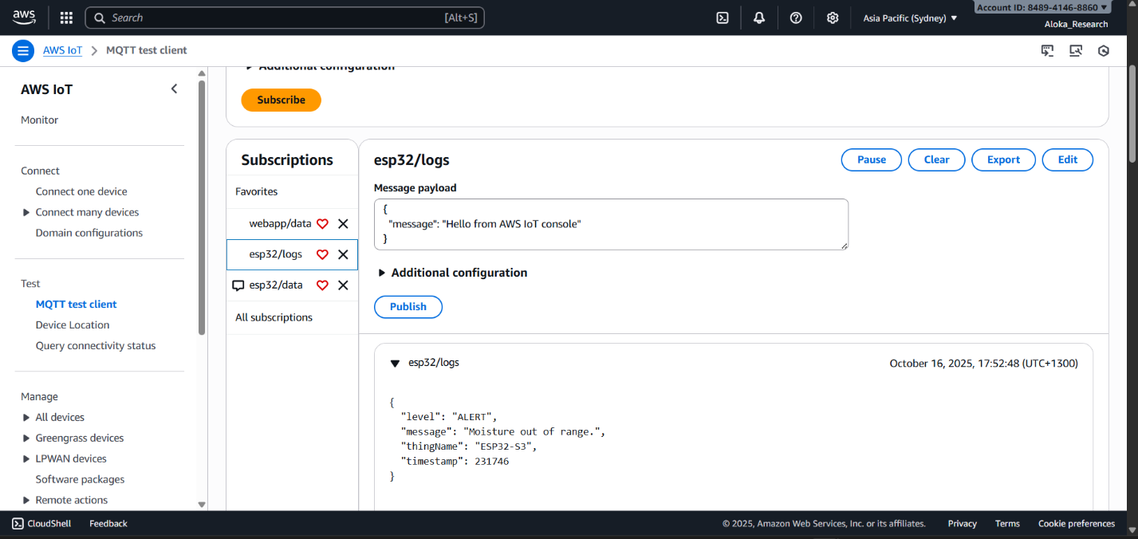
Figure 3: AWS IOT MQTT test client - the data is published into the logs, not to the webapp
- Alert published to esp32/logs.

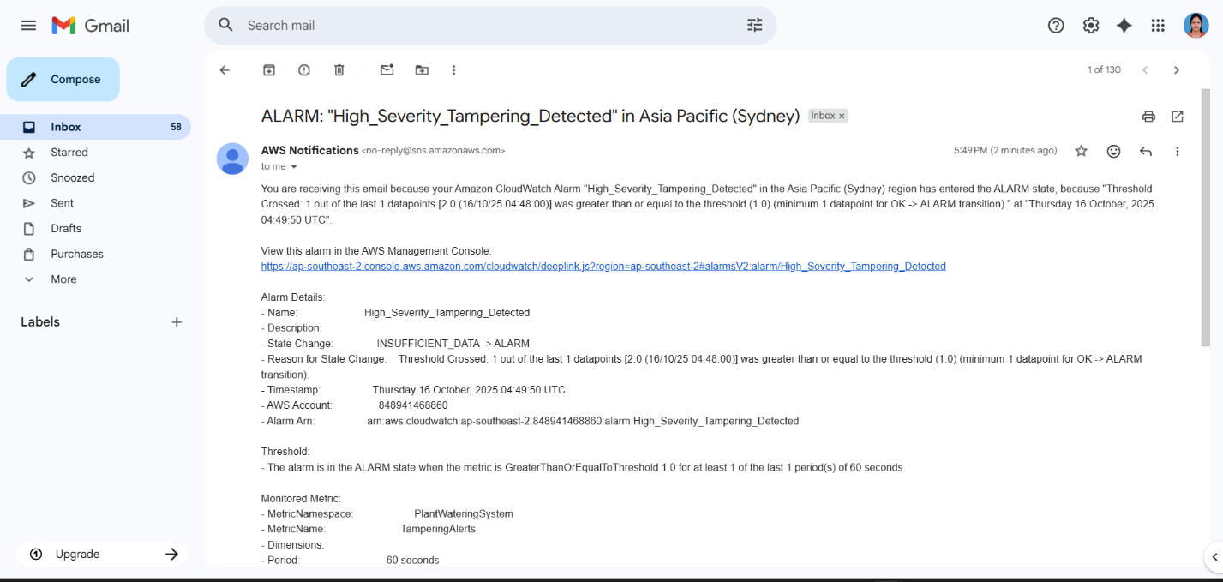
Figure 4: Receive an email Alarm - High Severity Tampering Detect from AWS
- CloudWatch/SNS email alert.
No invalid data reached esp32/data; dashboard holds prior values; cloud confirms detection and alerting.
Detection and Mitigation Mapping
Prototype Control | MITRE ATT&CK Mitigation ID | Mitigation Name | Function in Prototype
Firmware validation (validateSensorData) | M0818 (ICS), M1047 (Ent.) | Validate Program Inputs, Audit | Blocks/prevents invalid readings pre-publish; logs anomalies
Logging to esp32/logs and CloudWatch | M1047 (Enterprise) | Audit | Detailed anomaly forensic logging
CloudWatch alarm + SNS notification | M1069 (Ent.), M0819 (ICS) | Monitor/Alert/Operational Visibility | Automated, actionable alerts and anomaly detection
Mechanical sensor shielding (physical protection) | M0807 (ICS), M1051 (Ent.) | Restrict Physical Access | Prevents or deters physical access/modification

Details and justification:
- Validate Program Inputs/Audit: MITRE encourages device/app input validation and anomaly logging .
- Monitor/Alert: Automated cloud/edge alerts recommended by MITRE.
- Restrict Physical Access: Key OT/IoT defense for field hardware.​
Residual Risk and Recommendations
- Risk: Sophisticated attacks (gradual drift) may evade checks.
- Improvements: Sensor redundancy, cross-validation, tamper-evident hardware, and firmware hash attestation.
Chosen for high field relevance and repeatability, direct integrity effect, major decision impact, and compliance with proposal/academic criteria (Meneghello et al., 2019; Vardhan et al., 2023). Other device threats excluded due to practical constraints.
The Device Tampering scenario confirms effectiveness of onboard validation, alerting, and physical protection, fully aligned with MITRE ATT&CK T1565/T0831 and latest mitigations.

Device Layer — Threat 2: Sensor Data Injection
Overview and Context
Sensor data injection is a high-severity digital attack where an adversary, often armed with compromised credentials, publishes bogus but structurally valid sensor data directly to the cloud backend, bypassing the device. The attacker aims to corrupt farm decisions or poison historical records by submitting out-of-range or unrealistic values (Meneghello et al., 2023). In this project, the threat was simulated by publishing extreme payloads (e.g., "moisture_percent": 100, "temperature_c": 60, “humidity”: 100) to the esp32/data topic via MQTT.
MITRE ATT&CK Mapping
MITRE Domain | Tactic | Technique | Technique ID
Enterprise/ICS | Impact (Integrity Violation) | Data Manipulation | T1565
The technique matches MITRE’s “Data Manipulation” (T1565), defined as adversaries injecting or manipulating data to alter decision-making or records within industrial/IoT systems.

CVSS v3.1 Assessment
Metric | Value | Rationale
AV | N | Attack is remote via MQTT/Cloud
AC | L | Simple execution if credentials are available
PR | L | Requires valid credentials (stolen or weak password)
UI | N | No user interaction needed
S | U | Attack affects only system’s logical state
C | L | Negligible confidentiality loss
I | H | High: corrupted data results in poor analytics/automation
A | L | Low: brief loss of system integrity but little to no downtime
Vector: CVSS:3.1/AV:N/AC:L/PR:L/UI:N/S:U/C:L/I:H/A:L
Base Score: 7.3 (High)
Before Mitigation (Evidence)
With insecure rules, malicious payloads were accepted and processed without checks:
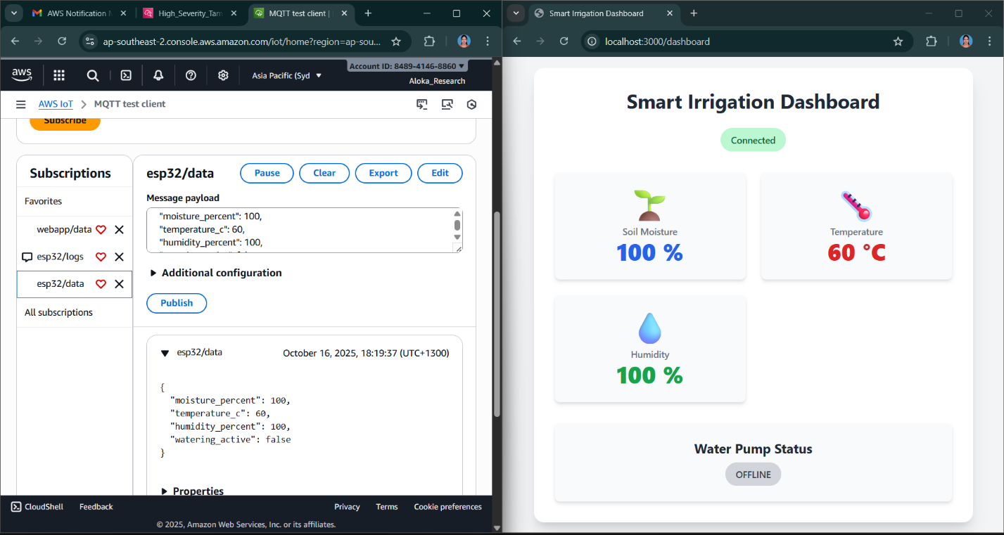
Figure 5: Sensor Data Injection Simulation Before Security out of Range Payload - Accepted by Cloud and Displayed on Dashboard
- Backend ingests, enriches, and stores invalid data—dashboard displays out-of-range values, poisoning farm controls and history.
After Mitigation
After mitigation, a comprehensive defense-in-depth strategy was implemented using a multi-tiered rule structure combined with centralized logging and alerting:
- Tier 1: Sensor Data Validation and Storage
Data is only written to DynamoDB if all sensor values are within strict, predefined safe ranges and originate from an authorized source IP. This ensures that only trustworthy and in-range data contributes to the core database.
- Tier 2: Invalid Data Handling and Logging
Any payload that fails the validation checks is not discarded but instead is republished to a designated IoT logs topic (e.g., esp32/logs). This allows easy review and forensic analysis of anomalous or malicious input attempts.
- Tier 3: Centralized Security Logging and Alerting
All anomalies, including validation failures and rule violations, are forwarded to AWS CloudWatch log groups. With centralized monitoring enabled, alerts can be generated on detection of suspicious events, triggering operator review or automated defense mechanisms.
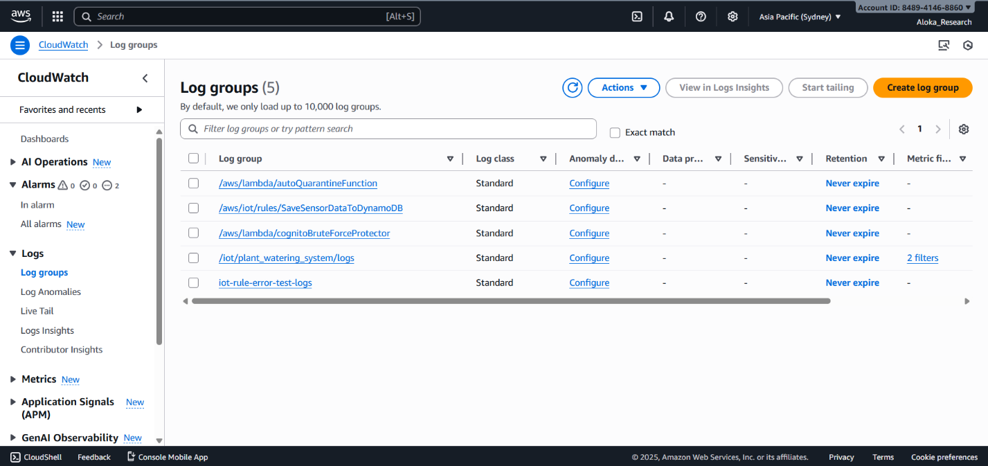
Figure 6: AWS CloudWatch Log Groups for Layered IoT Security and Forensic Monitoring
Results:
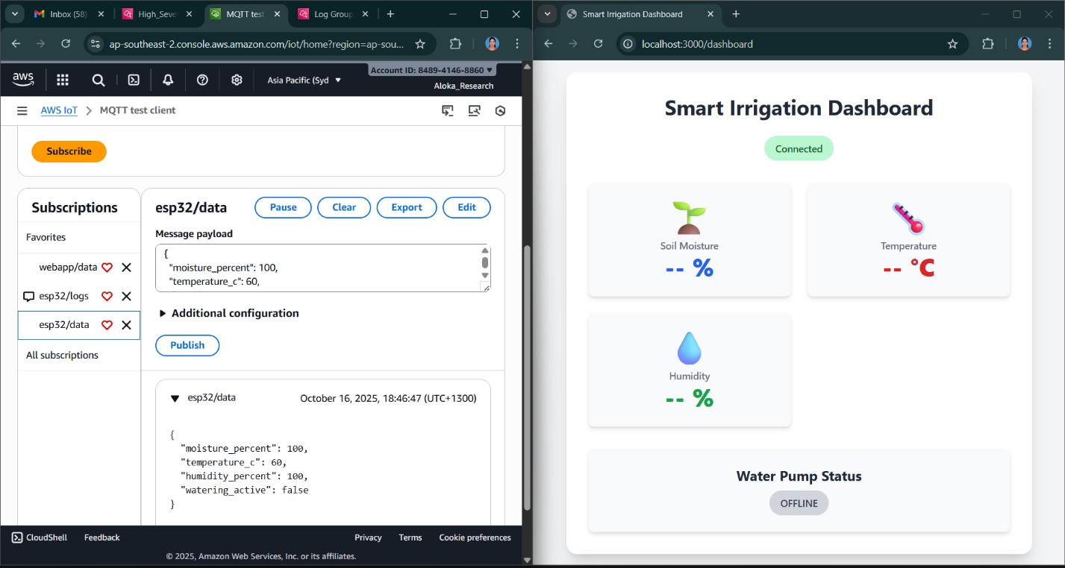
Figure 7: Invalid Data Rejected by IoT Rule and Not Displayed on Dashboard
- Out-of-range values do not appear on the dashboard.
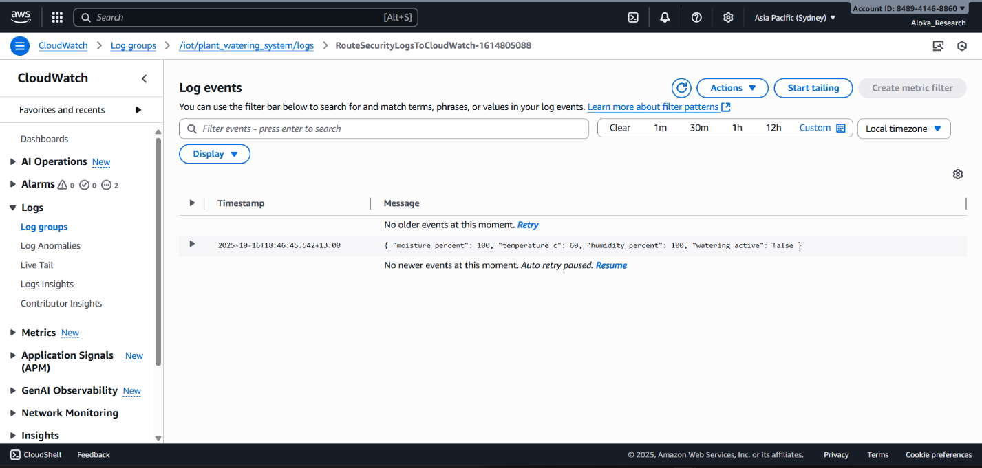
Figure 8: CloudWatch Log of Blocked Injection Event
- Anomaly is logged centrally (CloudWatch).

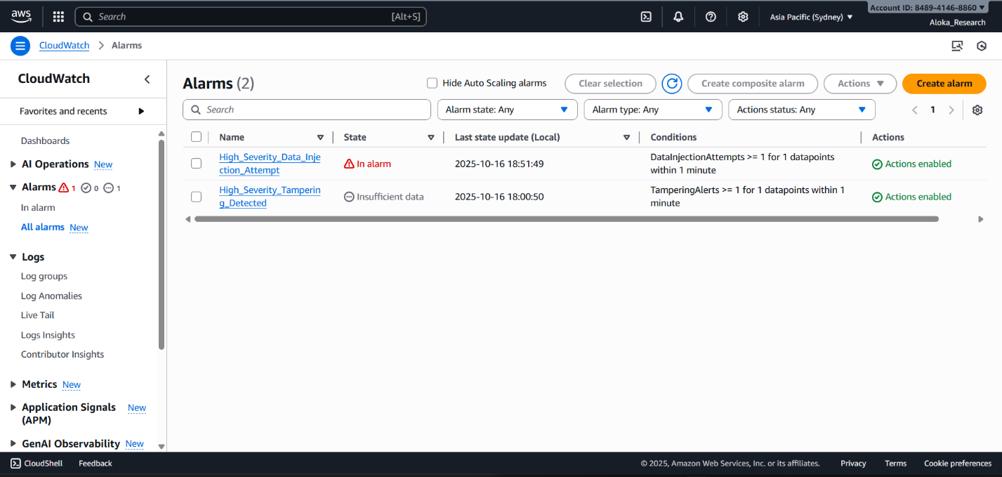
Figure 9: AWS IoT CloudWatch Alarm Triggered for Data Injection Attempt
- CloudWatch alarm triggers for injection attempt.

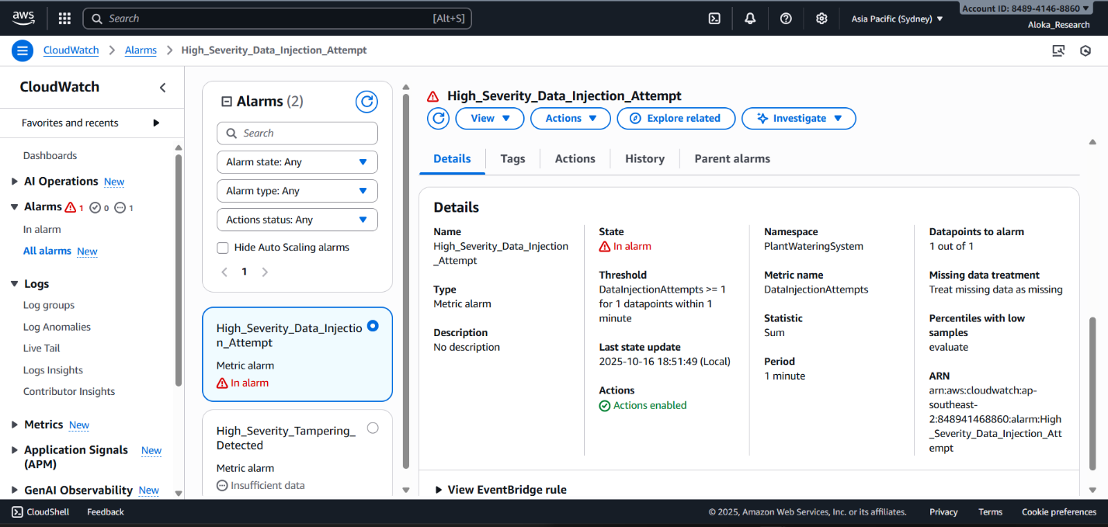
Figure 10: Overview of CloudWatch Alarm States for IoT Threat Detection
- Threat summary in cloud alarm console.

Figure 11: Email Notification of High Severity Data Injection Attempt
- Immediate security alert received by email.

Detection and Mitigation Mapping
Prototype Control | MITRE ATT&CK Mitigation ID | Mitigation Name | Function in Prototype
IoT Rule Payload Validation | M0818 (ICS), M1047 (Ent.) | Validate Program Inputs, Audit | Blocks invalid/cloud-injected MQTT values
Logging anomalies to esp32/logs and CloudWatch | M1047 | Audit | Centralized forensic and anomaly logging
CloudWatch alarm + SNS notification | M1069 (Ent.), M0819 (ICS) | Monitor/Alert/Operational Visibility | Automated high-severity alerting on anomalies
Credential management and network restrictions | M0800 (Ent.), M0807 (ICS) | Authorization Enforcement, Restrict Physical Access | Reduces risk of unauthorized injection
- Validate Program Inputs (M0818, ICS) / Audit (M1047, Ent.): Blocks/flags structured invalid data at the earliest point.
- Monitor/Alert/Operational Visibility (M1069/M0819): Enables rapid triage and containment of malicious payloads.
- Authorization Enforcement/Restrict Physical Access: Prevents misuse of credentials and limits unauthorized device access.
Residual Risk and Recommendations
- Risk: Slow, stealthy injections that mimic normal ranges may bypass rule-based validation.
- Improvements: Integrate machine learning anomaly analytics and enforce credential rotation policies.
This threat—cloud-side sensor data poisoning—is highly cited in recent IoT security literature for its real-world impact. Its selection in this research reflects a robust, literature-based approach, high feasibility for cloud simulation, and substantial operational relevance (Meneghello et al., 2023). Other cloud-injection variants or complex replay attacks were excluded due to scope and prototype feasibility.
The Sensor Data Injection scenario demonstrates how layered cloud validation, centralized logging, and rapid alerting restore cloud and farm data integrity after an advanced attack, fully mapped to MITRE ATT&CK T1565 and confirmed via empirical, auditable evidence.

Communication Layer — Threat 3: Denial of Service (DoS) via MQTT Flood
Overview and Context
Denial of Service (DoS) through MQTT flood is a prominent communication-layer attack in IoT-enabled smart agriculture. Here, an attacker with valid device credentials uses a script or automated tool to send high-frequency MQTT messages to the backend. This can overwhelm the cloud service and dashboards, drive up operational costs, and result in loss or delay of legitimate sensor readings and actuator commands.
MITRE ATT&CK Mapping
MITRE Domain | Tactic | Technique | Technique ID
Enterprise/ICS | Impact (Availability Loss) | Network Denial of Service | T1498
This mapping reflects an impact through excessive traffic, as recognized by ATT&CK's "Network Denial of Service" scenario.
CVSS v3.1 Assessment
Metric | Value | Rationale
AV | N | Attack launched remotely from anywhere with MQTT access
AC | L | Executed by scripts with low complexity
PR | L | Requires only valid credentials, widely guessed or stolen
UI | N | Entirely automated, no interaction needed
S | U | Scope unchanged, limited to public-facing/cloud endpoints
C | N | No exposure of confidential information
I | L | Limited—may distort real sensor order
A | H | Service can lag or stall, causing major downtime or degradations
Vector: CVSS:3.1/AV:N/AC:L/PR:L/UI:N/S:U/C:N/I:L/A:H
Base Score: 7.5 (High)

Before Mitigation (Evidence)
Under insecure/legacy cloud rules, MQTT flooding could not be detected or blocked. The result was visible at both the device and the dashboard, as well as in the cloud backend logs:
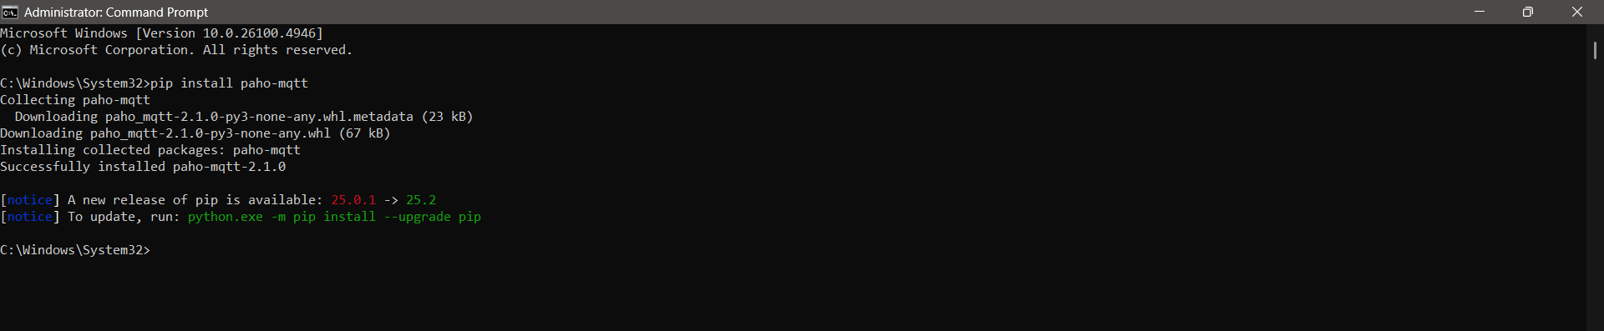
Figure 12: Paho_mqtt - Installed
- Prepares attack environment by installing a Python MQTT client.
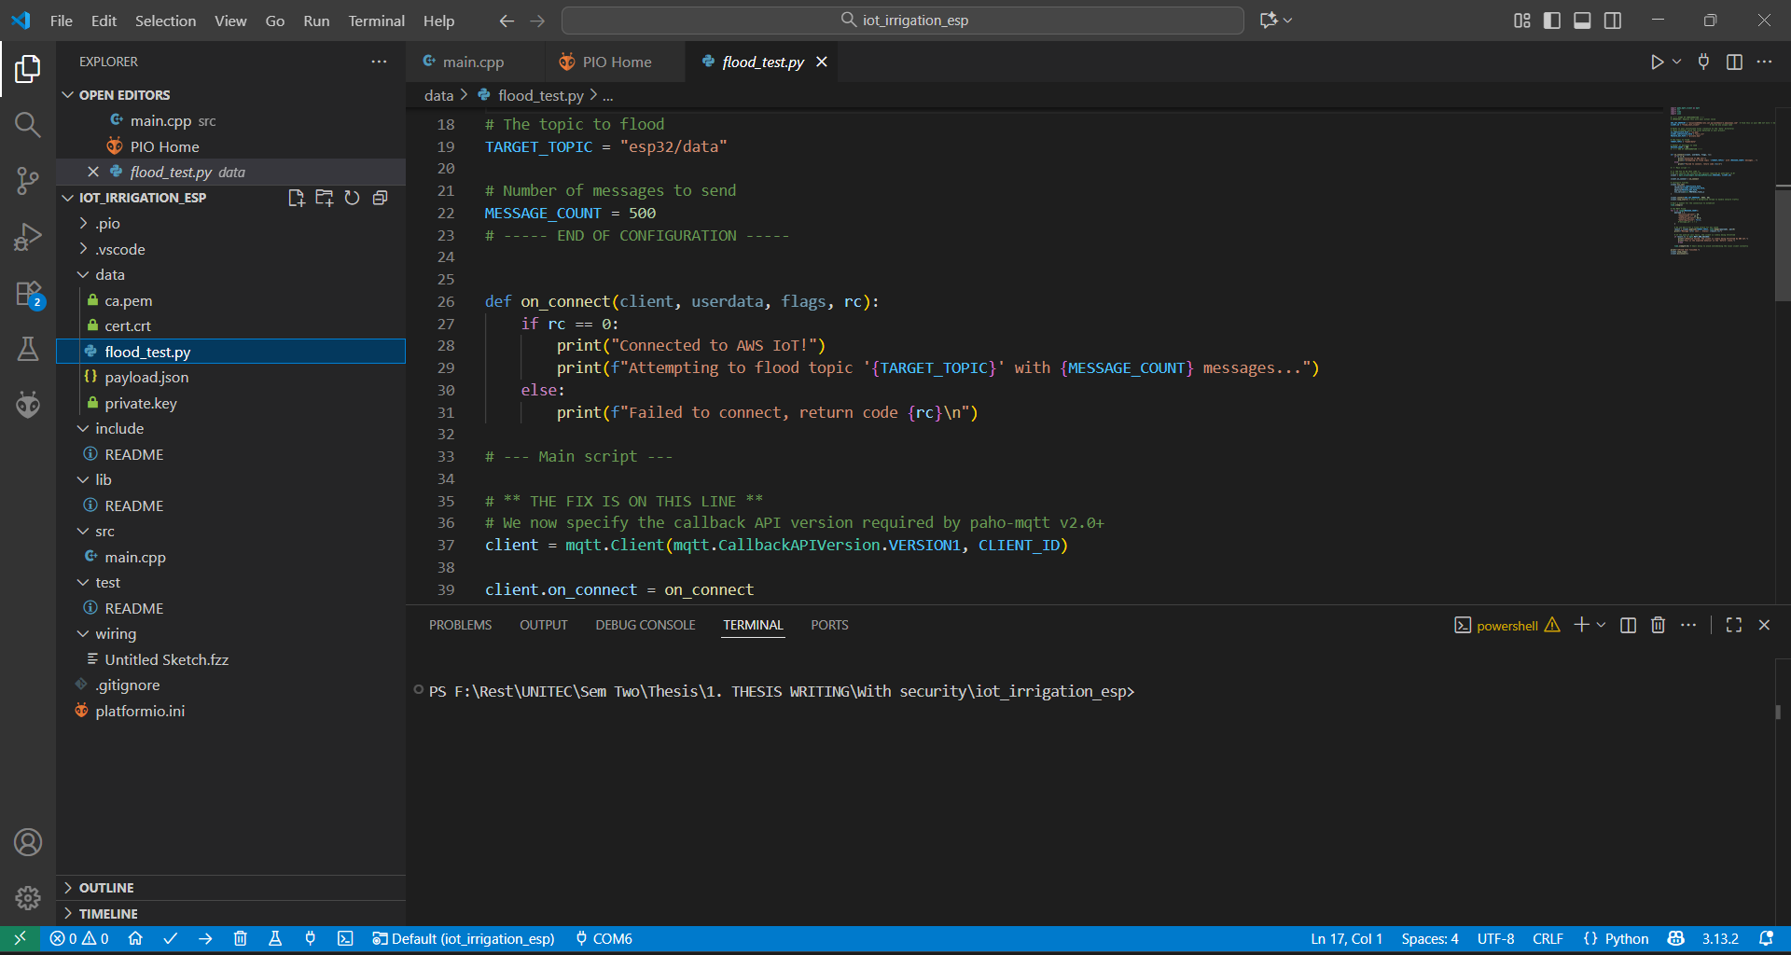
Figure 13: MQTT Flood attack configuration using Python script flood_test.py
- Shows script setup for rapid message publishing.

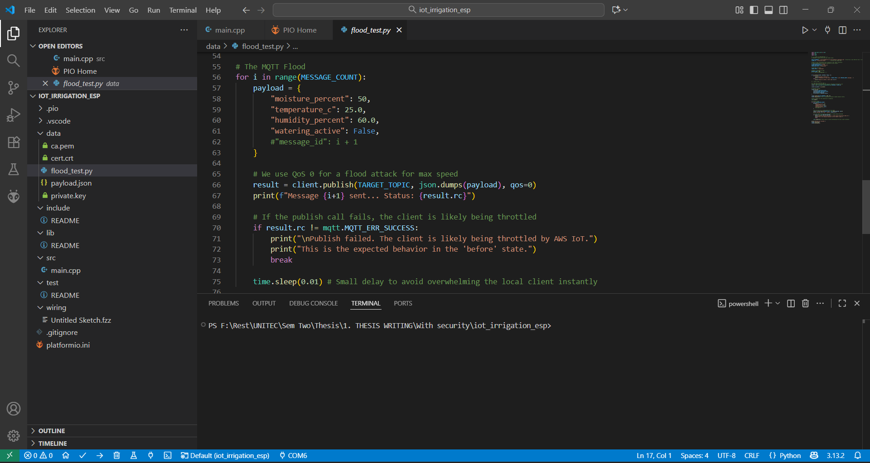
Figure 14: Python Flood Script for MQTT DoS Attack
- Flood script implementation.
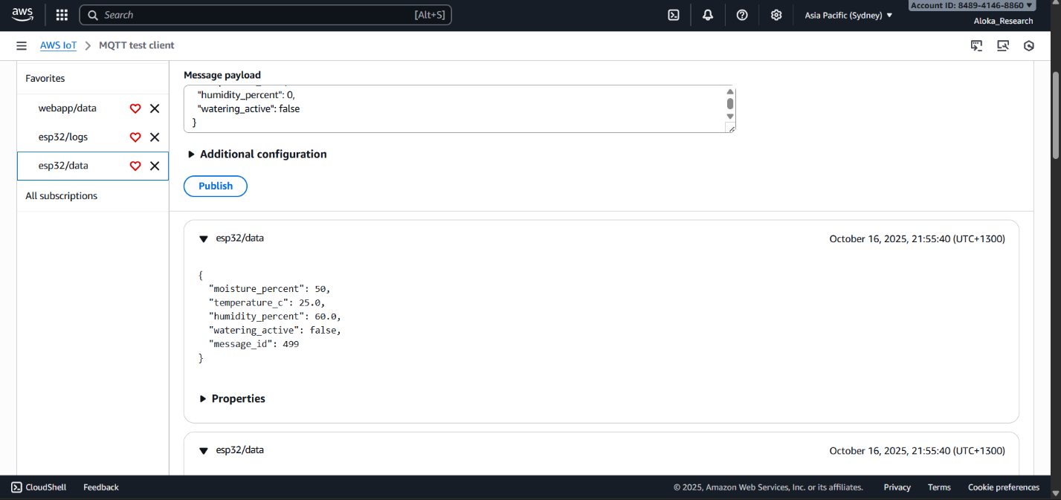
Figure 15: MQTT Test Client Showing Valid Data during Attack
- MQTT client synthesizing continuous data.
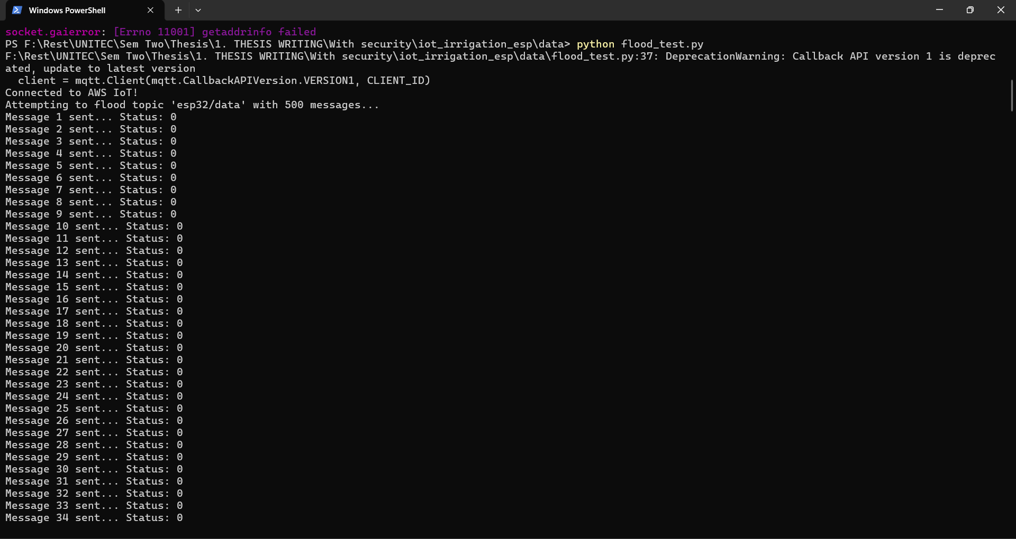
Figure 16: ESP32 MQTT Flood Script publishing 500 Messages
- Command line output from rapid-fire message posting.

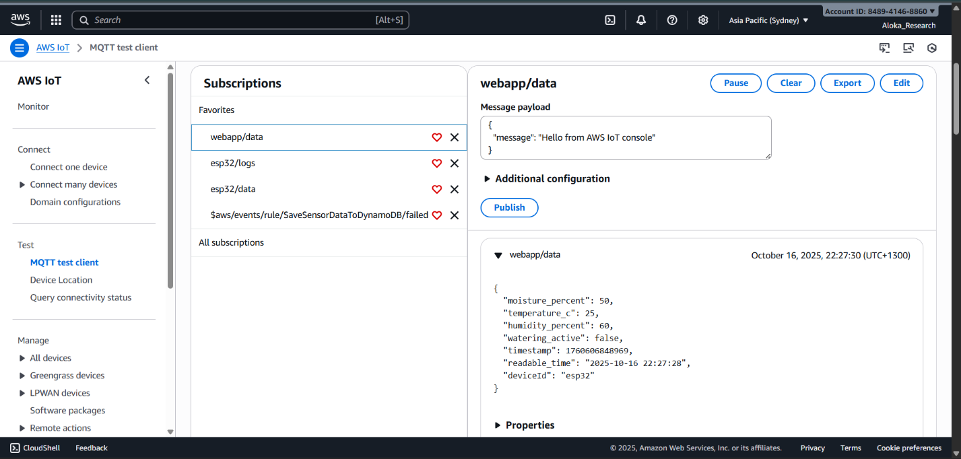
Figure 17: AWS IoT Web Dashboard Receiving frequent MQTT Data
- Web dashboard latency and message spike.
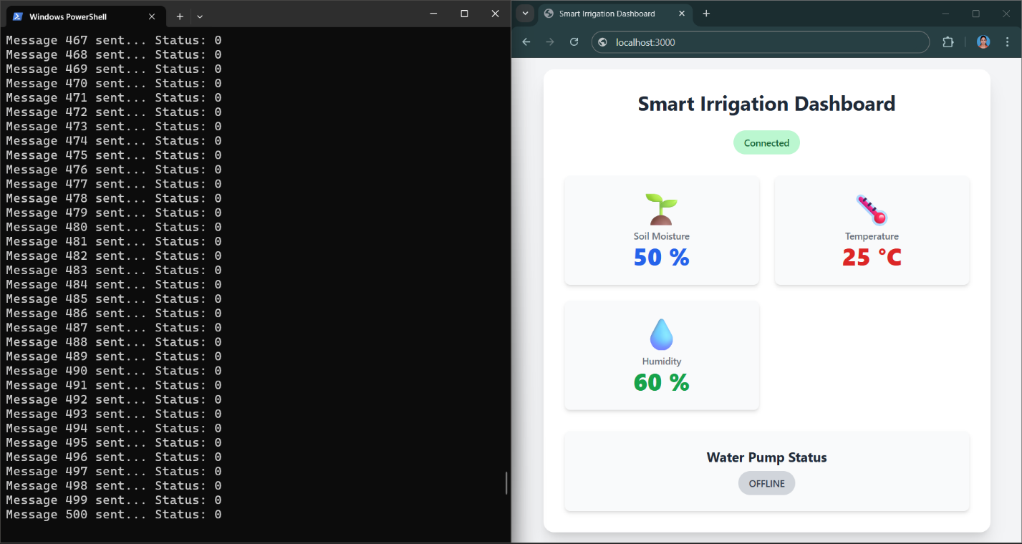
Figure 18: Smart Irrigation Dashboard during Flood Attack
- Local dashboard lags; irrigation status fails to update accurately.

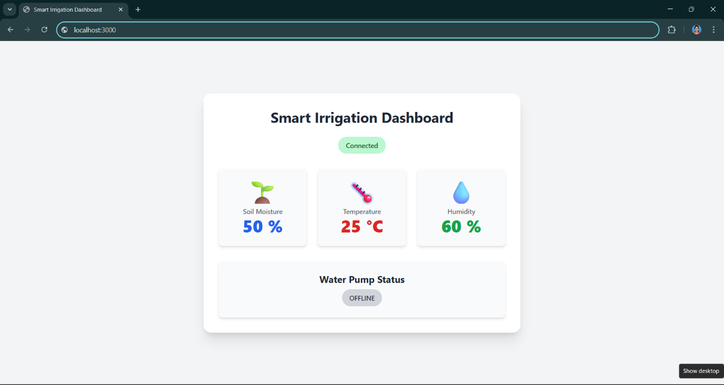
Figure 19: Dashboard receiving Repeated Updates
- Repeated, unmanageable data updates degrade dashboard usability.

After Mitigation (Defensive Monitoring, Rate-Limiting, and Alerting)
With AWS IoT Device Defender and advanced cloud rule enforcement, the system can now:
- Detect message rates per device/session.
- Automatically alarm, quarantine, or throttle devices exceeding safe thresholds.
- Instantly alert operators.
Observed results:
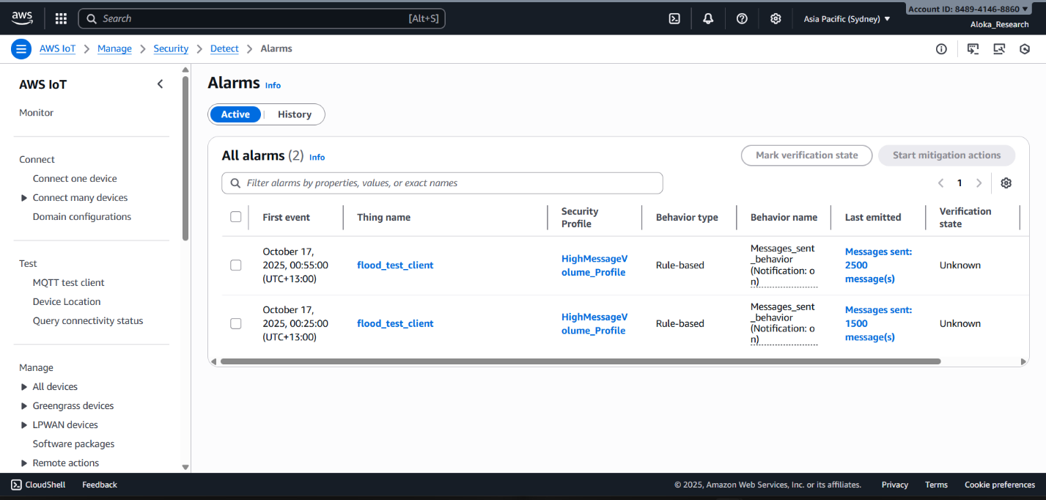
Figure 20: AWS IoT Device Defender Alarm trigger under MQTT Flood attack conditions
- Device Defender detects and alarms the DoS activity.
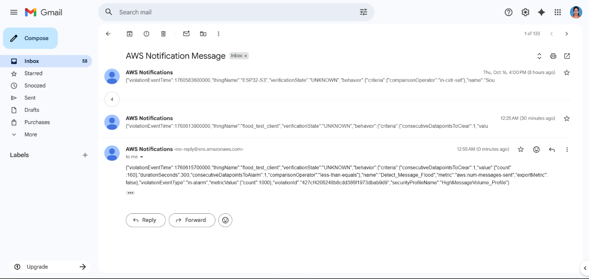
Figure 21: SNS Alert Emails for Message Flood Quarantine Events
- SNS sends immediate alarm notification.

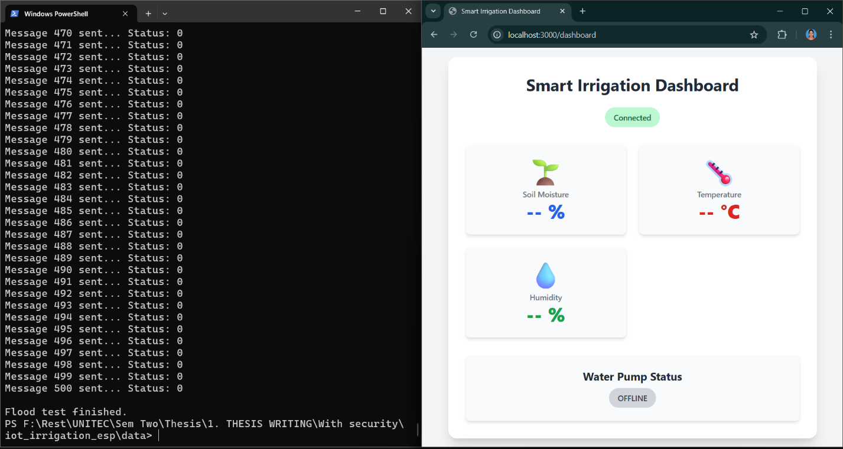
Figure 22: Dashboard and Flood Script Output After Security Frontend Data Protected
- Dashboard recovers, only reliable updates post-mitigation.

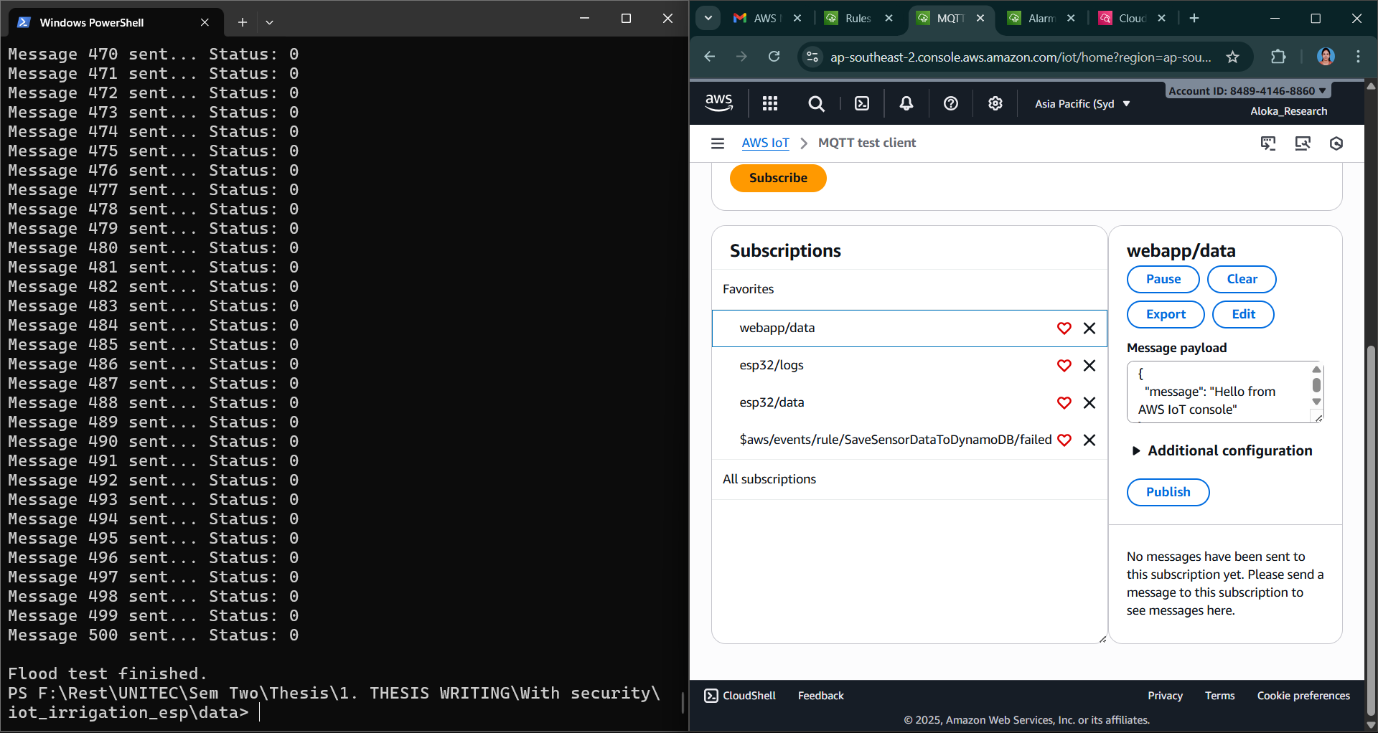
Figure 23: Flood test completed - Client throttled and Backend blocked MQTT AWS Console
- Flooding client is throttled/blocked by backend.

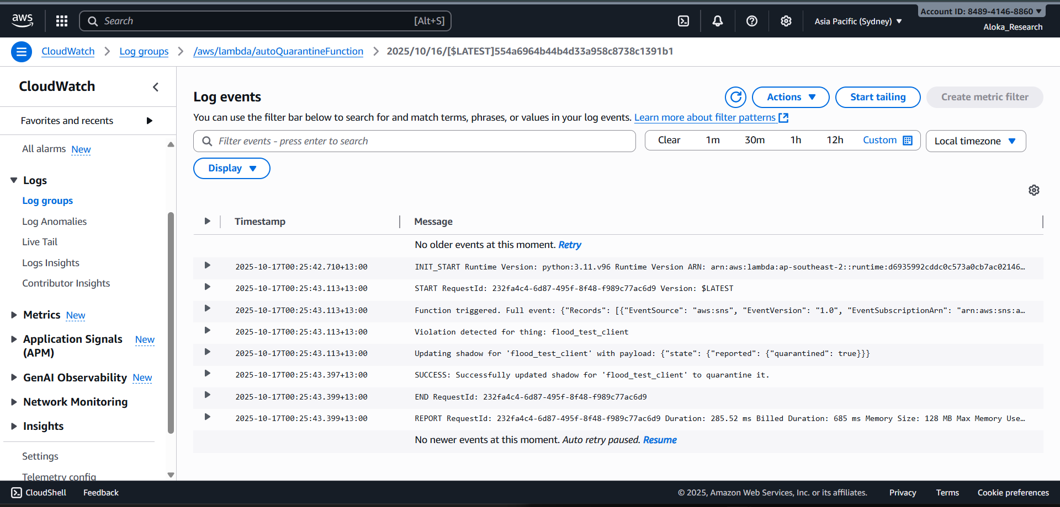
Figure 24: Lamda Auto Quarantine Log CloudWatch Device Quarantined After Flood Detection
- CloudWatch logs show device automatically quarantined after attack detection.
Detection and Mitigation Mapping
Prototype Control | MITRE ATT&CK Mitigation ID | Mitigation Name | Function in Prototype
Device Defender message rate thresholds | M1035 (Ent.), M0802 (ICS) | Network Traffic Rate Limiting/Monitor | Detects, alarms, and quarantines flood sources
Automated throttling by backend | M1035, M0802 | Network Traffic Rate Limiting | Prevents further overload, restores service reliability
SNS & CloudWatch alarms | M1069 (Ent.), M0819 (ICS) | Monitor/Alert/Operational Visibility | Real-time operator alerts, centralized incident response
Quarantine/connection refusal | M0800 (Ent.), M0807 (ICS) | Authorization Enforcement/Restrict Access | Isolates offender, prevents repeat attacks
These mitigations are formally recognized in both MITRE Enterprise and ICS matrices as best-practice responses to protocol-based DoS.

Residual Risk and Improvements
- Risk: Flooding at low/variable rates to evade fixed thresholds.
- Recommendation: Use adaptive anomaly detection, extend behavior monitoring, enforce periodic credential audits.
MQTT flood attacks are a critical threat described in both current industrial security publications and IoT-specific research (ENISA, 2025; Adewusi et al., 2024). This scenario directly validates research methodology and security platform readiness against real-world communications abuse.
The Denial of Service (DoS) via MQTT Flood threat scenario demonstrates the effectiveness of layered defensive strategies—real-time monitoring, rate-based prevention, active alerting, and automated quarantine—fully mapped to MITRE ATT&CK T1498. Before/after images document how mitigations restore service integrity, protect cloud costs, and preserve the operational resilience of smart irrigation systems.

Communication Layer — Threat 4: Device Credential Theft & Impersonation
Overview and Context
Device credential theft and impersonation is a major threat in distributed IoT. Here, an attacker gains temporary (even brief) physical access to a deployed ESP32 device in the field, connects to debugging or programming interfaces (e.g., UART, JTAG), and copies its flash memory. This enables extraction of the unique TLS client certificate and private key, which are normally used to securely authenticate the device to AWS IoT. Using these, the adversary can “clone” the device—sending convincingly valid data to the cloud from anywhere, even globally, appearing fully legitimate to cloud authentication.
MITRE ATT&CK Mapping
MITRE Domain | Tactic | Technique | Technique ID
Enterprise/ICS | Credential Access, Initial Access | Valid Accounts | T1078
This attack fits MITRE T1078 “Valid Accounts,” where adversaries use legitimate credentials to gain access and accomplish malicious goals.

CVSS v3.1 Assessment
Metric | Value | Rationale
AV | N | Attack proceeds remotely once creds stolen
AC | L | Straightforward with physical access/tools
PR | N | Theft requires no prior device credentials
UI | N | Automated, no user action needed
S | U | Attack is contained to the device’s scope
C | L | Data can be leaked, but only device data
I | H | High—altered or forged sensor input pollutes history/data
A | L | Legitimate device may be knocked offline via shadow conflicts
Vector: CVSS:3.1/AV:N/AC:L/PR:N/UI:N/S:U/C:L/I:H/A:L
Base Score: 8.1 (High)

How to Emulate (Custom Atomic Test)
- Check the legitimate/“home” public IP (e.g., from office WiFi):
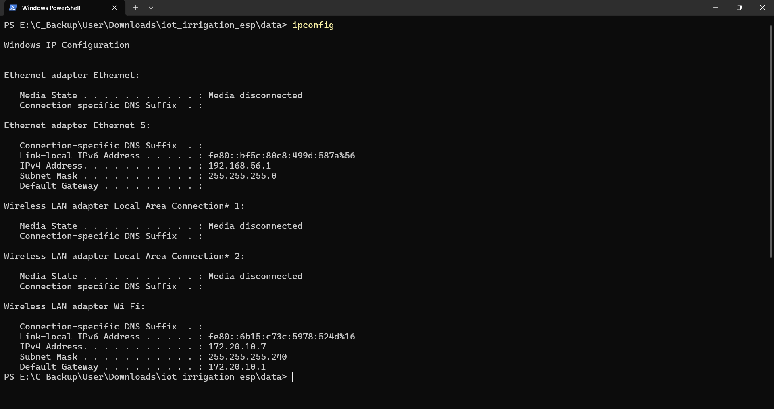
Figure 25: ipconfig - showed original correct network
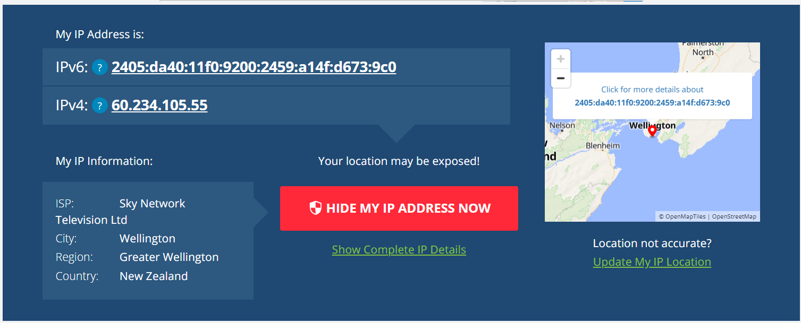
Figure 26: Device IP Address of the System(Legitimate)
- Switch the attacker device to a new public IP (e.g., use a phone or mobile hotspot):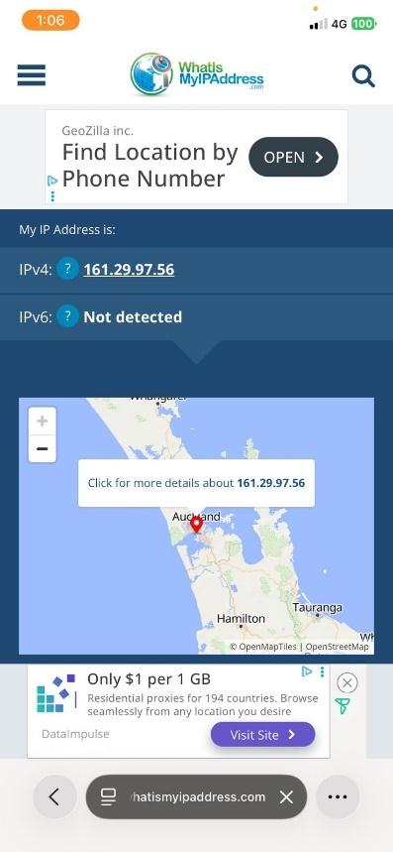
Figure 27: Mobile Hotspot public IPV4 - attacker routing
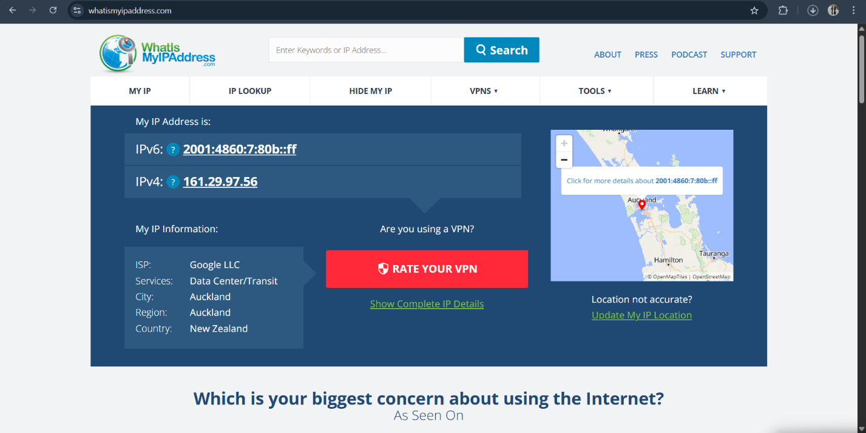
Figure 28: Attacker 1 - IP lookup - confirmed hotspot IP

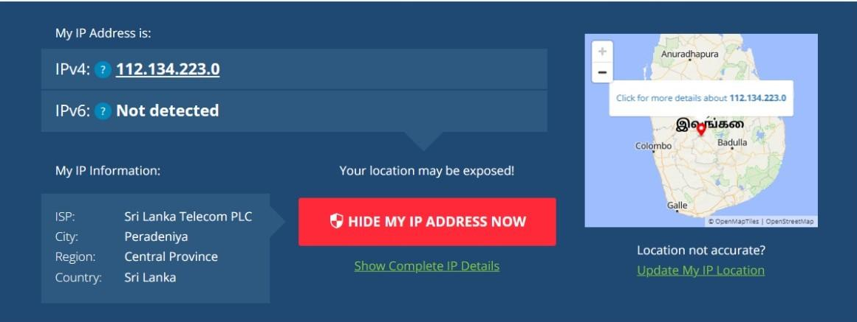
Figure 29: Attacker 2 - Public IP Address

- Use mosquitto_pub with copied (stolen) device TLS materials to publish:
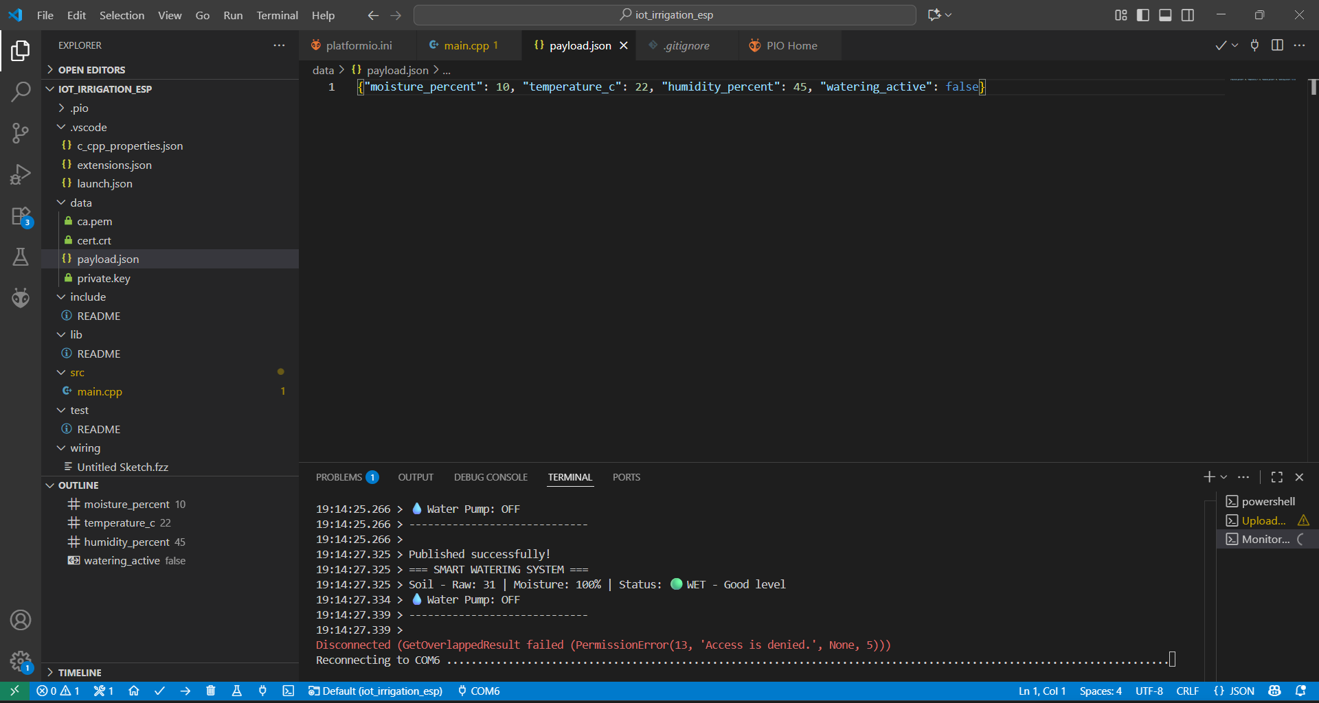
Figure 30: Payload JSON File used for Attack - Injection
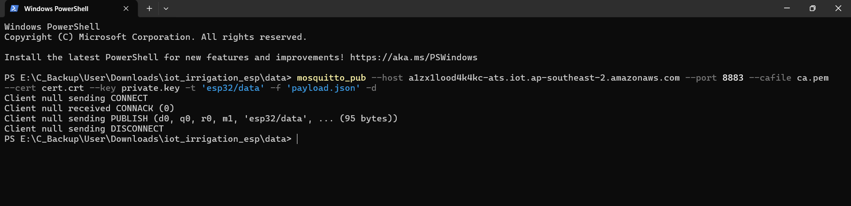
Figure 31: Successful unauthorized MQTT publish ( From Attacker - Laptop via phone hotspot)

Before Mitigation (No Cloud-Side IP Monitoring)
- Behaviour: When an attacker connects from an unknown/untrusted network with stolen credentials, AWS IoT accepts the connection because the certificate is valid.
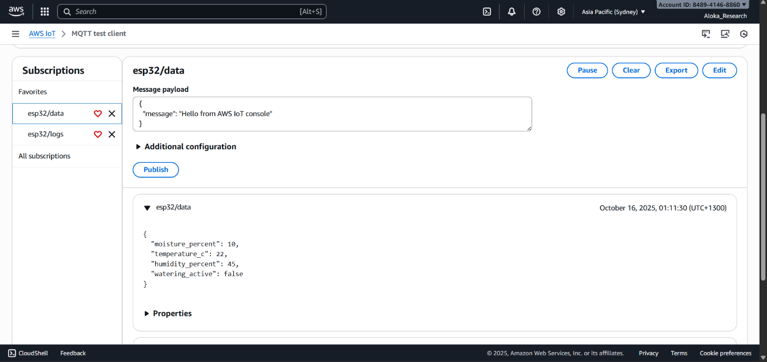
Figure 32: AWS IoT MQTT test client showing received spoofed data
- Shows attack data successfully arriving in the backend after spoof.
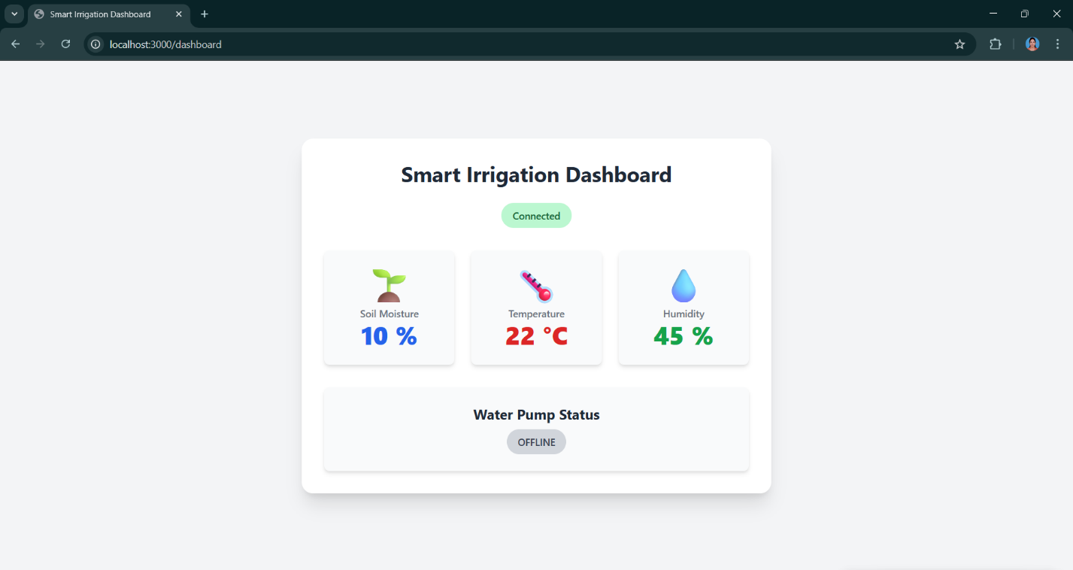
Figure 33: IoT Dashboard displaying Spoofed Sensor Data during attack

- Malicious data displayed on the web dashboard, indistinguishable from legitimate input.
- Result: The esp32/data topic and DynamoDB receive attacker-forged data, corrupting the trusted data-plane. No alerts are raised.

After Mitigation (Preventative Cloud Rules & Device Defender IP Monitoring)
A multi-layered monitoring and rule-based prevention process completely prevents credential re-use and detects location-based anomalies:
- AWS IoT Rule Update: SaveSensorDataToDynamoDB restricts data acceptance to trusted device IPs only.
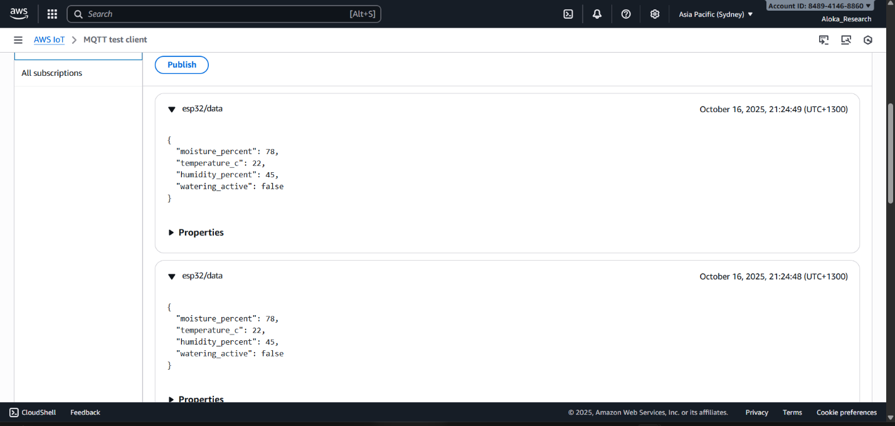
Figure 34: AWS MQTT test client blocking Unauthorized Data Injection
- Attack attempt is blocked; malicious data does not reach backend/DynamoDB.
- Device Defender Static IP Profile: Detects and alarms any connection from non-whitelisted IPs, triggering immediate notifications.
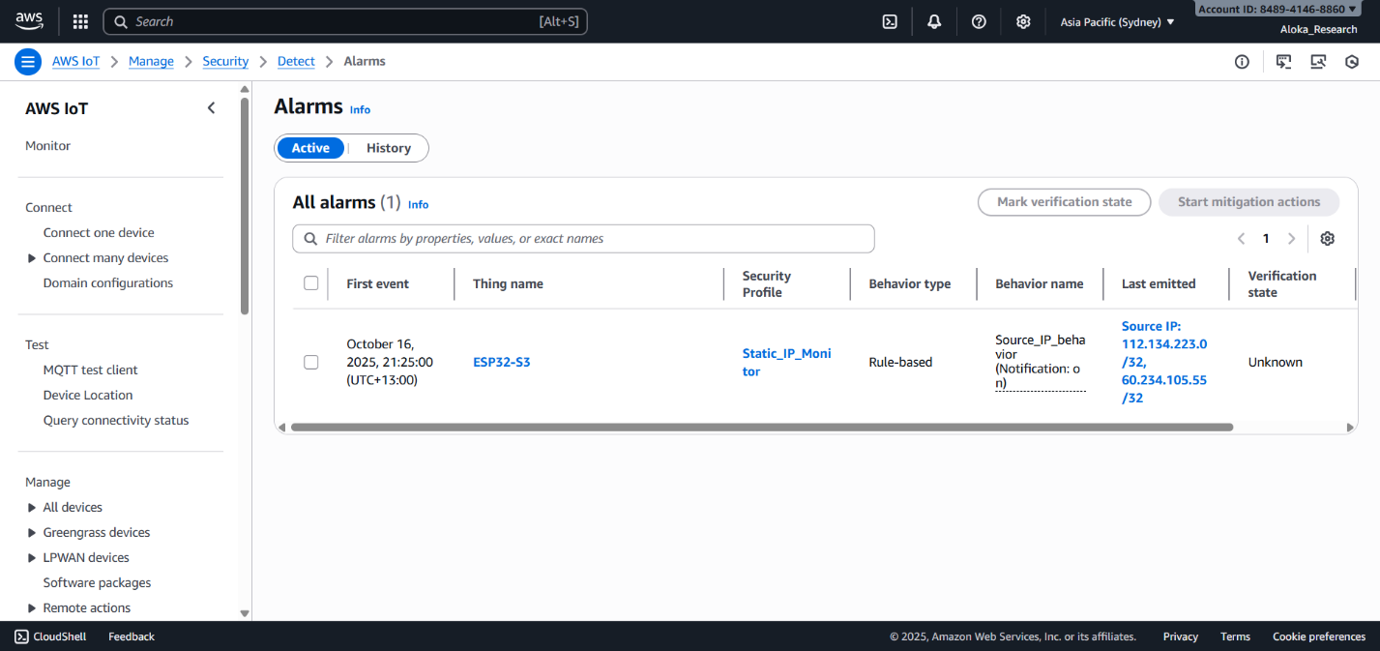
Figure 35: AWS IoT Device Defender Alarm Dashboard
- Dashboard view of real-time IP-based breach detection.
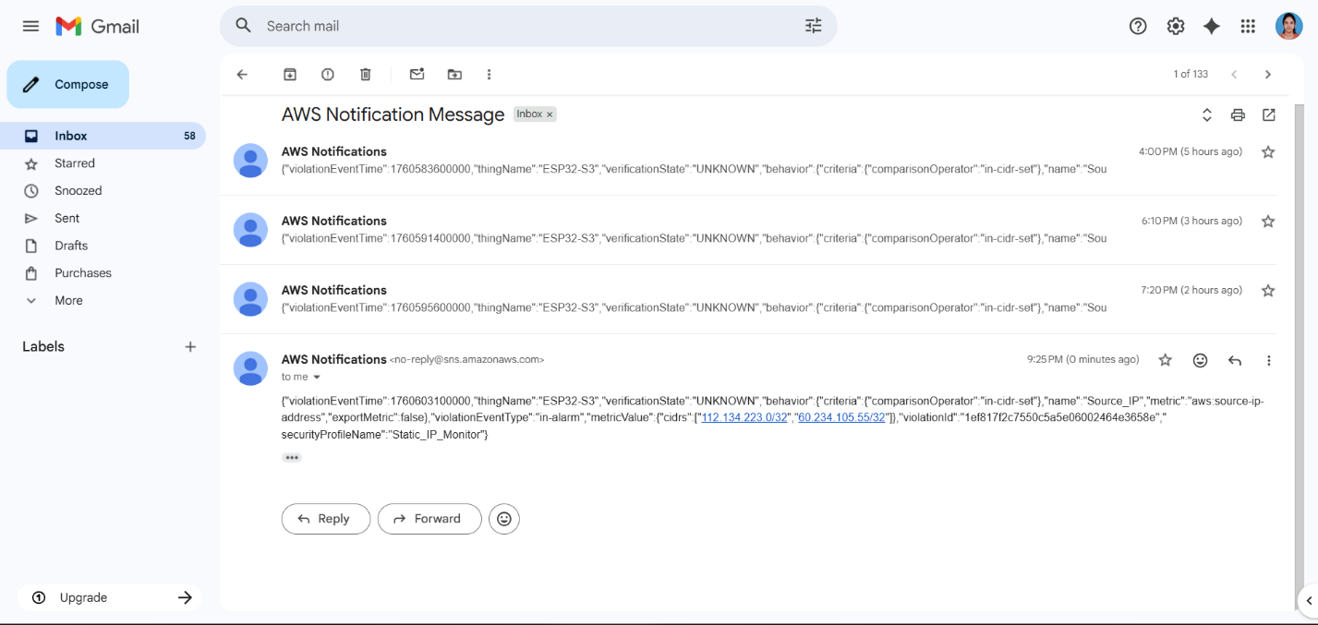
Figure 36: AWS SNS Email notification of IP Violation
- Security team instantly alerted to the unauthorized attempt.
Result:
- Only legitimate device data is accepted; attacker-generated data is silently dropped, not shown in frontend or saved.
- Real-time alerts enable fast incident response.

Detection and Mitigation Mapping
Prototype Control | MITRE ATT&CK Mitigation ID | Mitigation Name | Function in Prototype
Cloud-side IP whitelisting & rule enforcement | M1037 (ICS), M1042 (Ent.) | Restrict Unauthorized Access | Only trusted IP/device can publish; all else blocked
Device Defender static IP behavior rule | M1047 | Audit | Triggers alarms for connections from new locations
Credential management / rotation | M0800, M1036 | Authorization Enforcement, Key Management | Limits window of exploitation
MITRE recognizes these as standard mitigations against credential misuse and impersonation

Residual Risk and Improvements
- Risk: An attacker on the trusted network could still exploit stolen keys.
- Improvements: Enforce regular key rotation, defense-in-depth with anomaly detection (e.g., sudden policy changes, connection time anomalies).
Device credential theft and impersonation is a well-documented “Valid Accounts” threat highlighted in both academic and industrial security analyses for IoT. This experiment is chosen for high feasibility, impact on system integrity, and empirical demonstrability.
The Device Credential Theft & Impersonation threat scenario proves how cloud rule enforcement, IP-aware access control, and real-time monitoring neutralize advanced credential misuse. Before/after evidence demonstrates the effectiveness of these mitigations in fully blocking stealthy attackers, even with legitimate certificates—fulfilling research and industry standards.

Cloud Layer — Threat 5: Cloud Privilege Escalation via Overprivileged Web User Role
Overview and Context
Cloud privilege escalation is a critical cloud-layer threat where an attacker compromises web application user credentials and capitalizes on flawed IAM roles. In this scenario, the AWS Cognito Identity Pool assigns authenticated web users an IAM role with dangerously broad permissions (iot:*). The attacker uses standard AWS CLI commands to log in, obtain temporary AWS credentials, and assume a role from which they can dismantle security controls, read, write, and delete resources, and disrupt the overall IoT backend.
MITRE ATT&CK Mapping
MITRE Domain | Tactic | Technique | Technique ID
Enterprise | Privilege Escalation | Valid Accounts/Abuse Elevation Control Mechanism | T1078, T1548
This attack leverages “Valid Accounts” (T1078) for initial access, and “Abuse Elevation Control Mechanism” (T1548) to exploit permissions for unauthorized power.
CVSS v3.1 Assessment
Metric | Value | Rationale
AV | N | Executed remotely from any network
AC | L | Uses legitimate login and standard AWS CLI
PR | L | Only requires low-privilege credentials
UI | N | Entirely scriptable, no user interaction needed
S | U | Limited to assigned role’s privilege (but dangerous if overprivileged)
C | H | High impact—attacker can access sensitive cloud and device data
I | H | High—permissions can be abused to modify or poison all cloud state
A | H | High—attacker can un-do or delete critical protections, causing system-wide outage
Vector: CVSS:3.1/AV:N/AC:L/PR:L/UI:N/S:U/C:H/I:H/A:H
Base Score: 9.1 (Critical)

How to Emulate (CLI Attack Chain)
- Phase 1: Log In as Web User
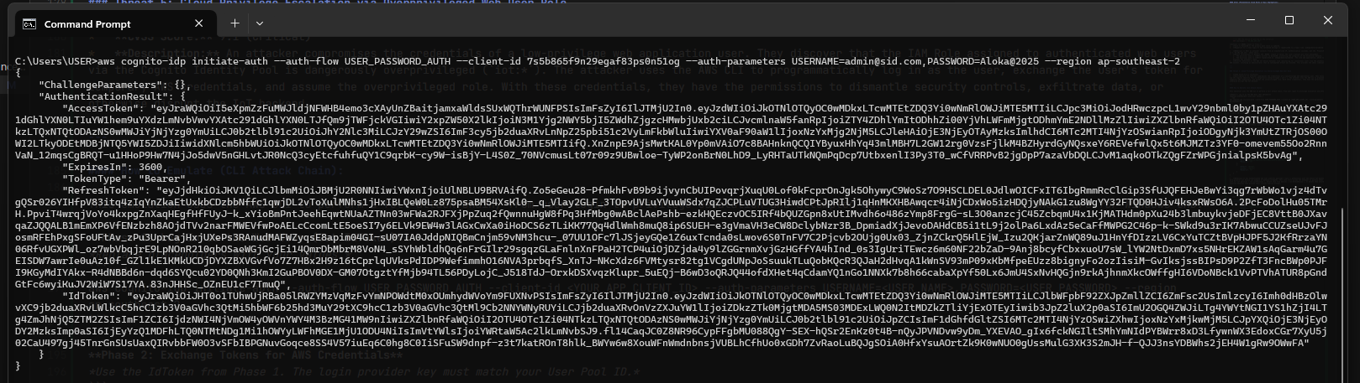
Figure 37: Obtaining the ID Token
  - Run AWS CLI to authenticate and obtain an IdToken.
- Phase 2: Exchange for Temporary Credentials
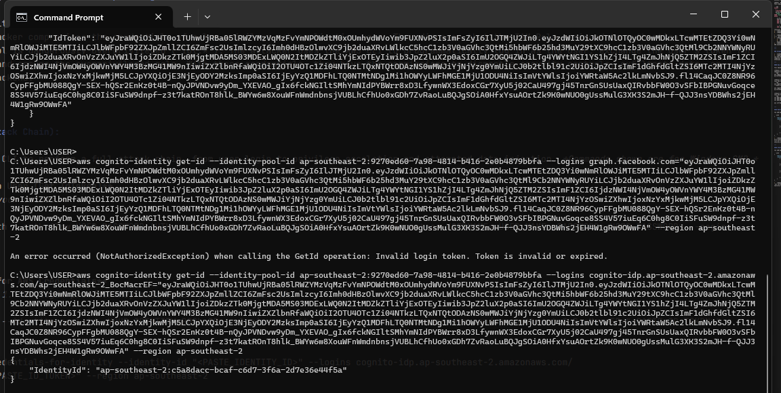
Figure 38: Generating Temporary AWS Identity
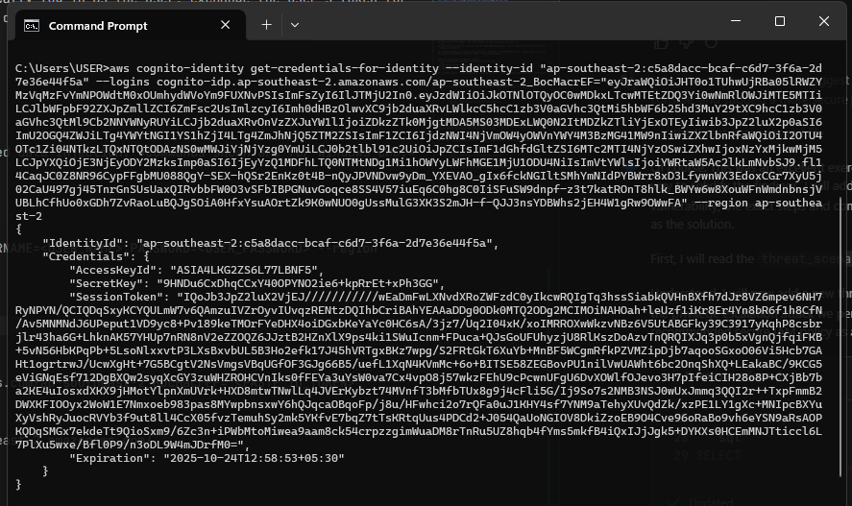
Figure 39: Retrieving Temporary Access Keys
  - Use IdToken to get temporary credentials (Access Key, Secret Key, Session Token).
- Phase 3: Assume Role & Attack
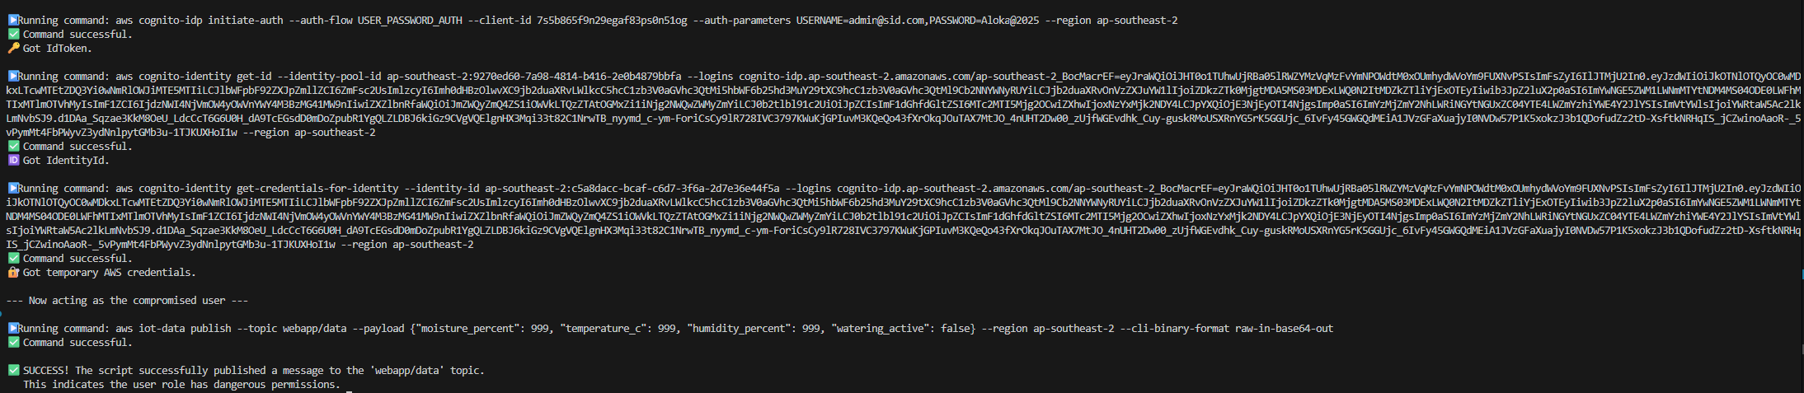
Figure 40: Execution of the Attack Script
  - Publish malicious payload, list, or modify policies or data in the cloud with excessive rights.

Before Mitigation (Insecure IAM Role)
- The Cognito-authenticated role for app users is dangerously permissive, granting "iot:*" and "Resource": "*".
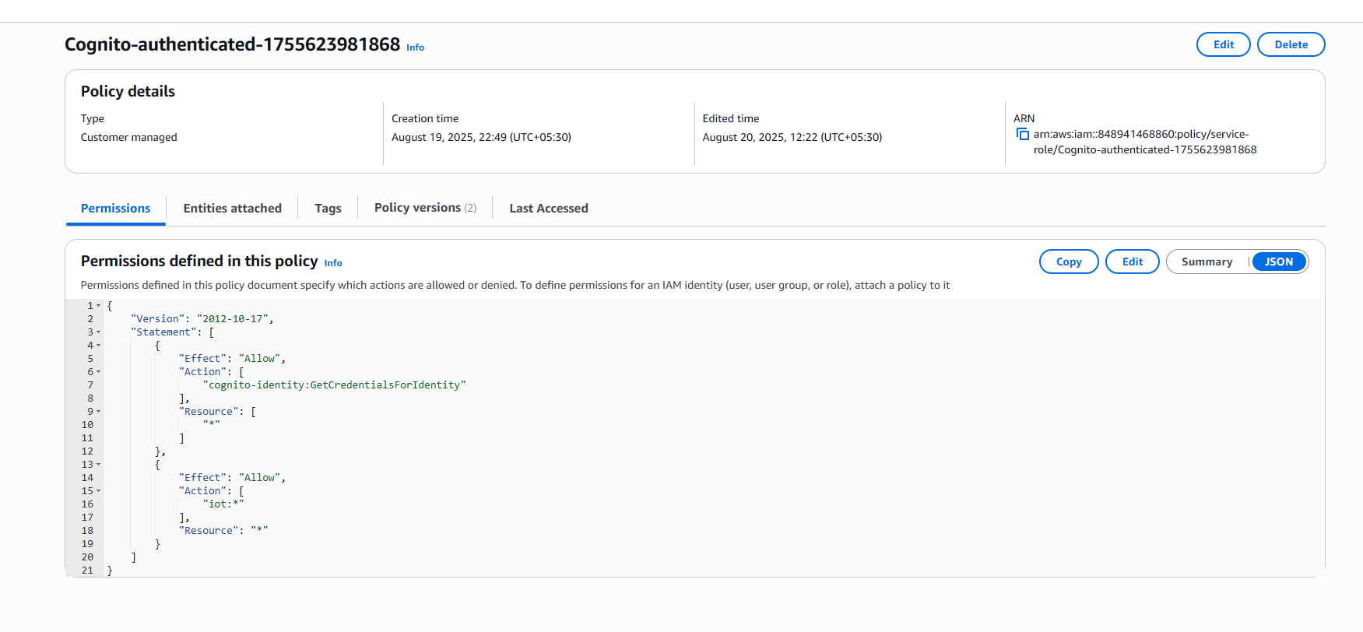
Figure 41: Overprivileged Cognito IAM Policy
- Any authenticated user can:
  - Publish or alter any topic, attempt to bypass cloud-level rules
  - Attempt direct attacks on device or security policies.
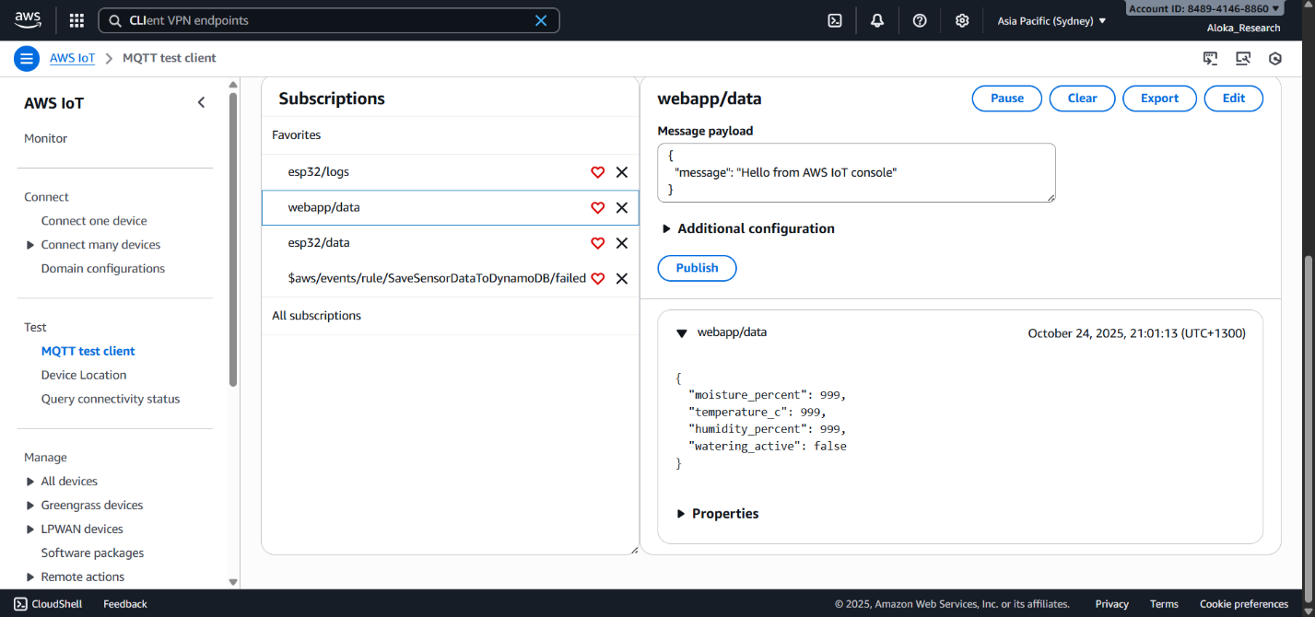
Figure 42: AWS IoT MQTT Test Client showing Malicious Payload
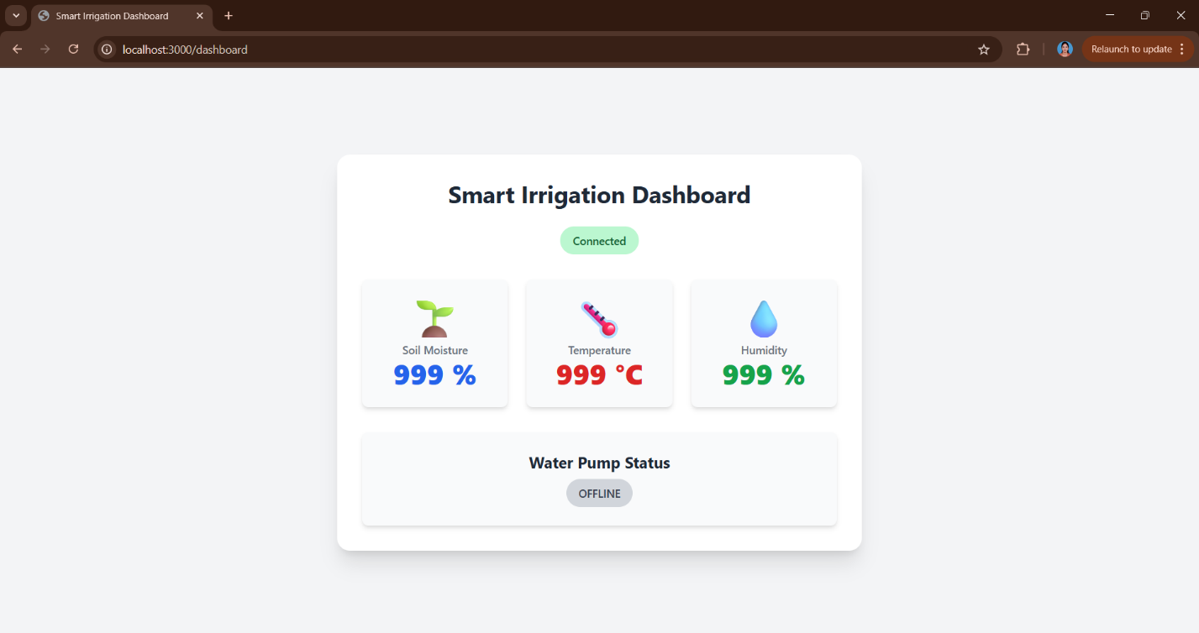
Figure 43: Injected Fake Sensor Data Displayed on Dashboard
- While some defensive IoT policies may block certain actions, overprivileged roles still allow reconnaissance, enumeration, and attacks on the security architecture itself.
After Mitigation (Secure IAM Role — Least Privilege)
- IAM Role is restricted to only needed actions for web users (Connect, Subscribe, Receive on specific frontend topics).
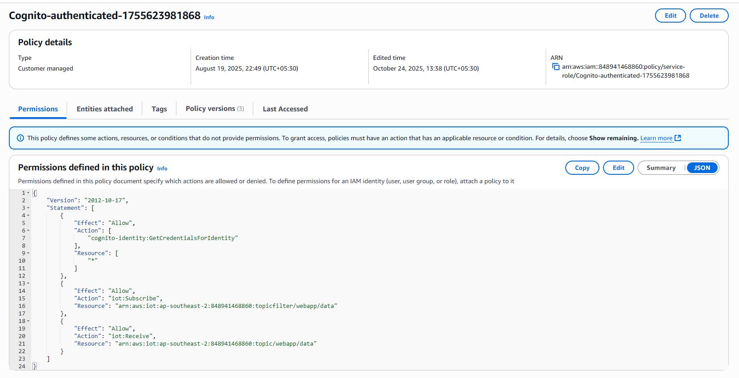
Figure 44: Secured Policy
- This shows the restricted policy statement.
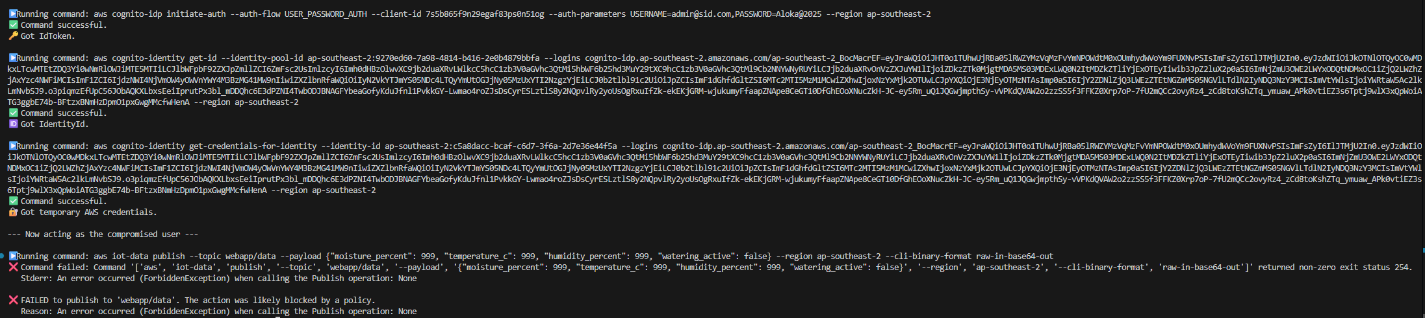
Figure 45: After Secure Policy - Attack
- Attempts to exploit these permissions but receives a ForbiddenException.
- Behavior: Attack attempts to publish or list/alter IoT resources are blocked, and only read-only access to allowed topics is enabled. Principle of Least Privilege is enforced.
Detection and Mitigation Mapping
Prototype Control | MITRE ATT&CK Mitigation ID | Mitigation Name | Function in Prototype
IAM policy scoping and review | M1015 (Ent.) | Least Privilege Principle | Reduces attack surface, restricts dangerous roles
Defense in depth (layered IoT/wildcard) | M1016 (Ent.) | Application Layer Filtering | Prevents privilege misuse before acting
Regular credential/key rotation | M1036 (Ent.) | Key/Token Management | Minimizes useful lifetime for stolen credentials
MITRE formally encourages scoping roles (M1015), application filtering (M1016), and timely credential rotation (M1036) as standard defense.
Residual Risk and Recommendations
- Risk: Policy misconfiguration or IAM drift could re-enable overprivilege. Stolen admin credentials would evade these mitigations.
- Recommendation: Enforce regular review of all roles/policies, automate IAM drift detection, alert on new privilege escalation paths.
Cloud privilege escalation through overprivileged roles is the top-ranked attack vector in cloud security research. This scenario is included due to its high systemic risk, ease of demonstration with real-world CLIs, and relevance for operational IoT backend protection.
This attack scenario illustrates the immense risk of excessive privilege in cloud IAM. Defensive effort—constraining roles and permissions to only what is needed—not only blocks known attack chains, but also neutralizes zero-day privilege escalation attempts, as proven by before/after test evidence.

Cloud Layer — Threat 6: Cloud Data Integrity Violation (Incorrect or Manipulated Data Stored in DynamoDB)
Overview and Context
A Cloud Data Integrity Violation occurs when an attacker injects false or manipulated sensor readings via a valid or impersonated channel, leading to the corruption of historical data within DynamoDB. This can mislead automated decisions, damage crops, or disrupt operations—especially critical in data-driven smart agriculture. The threat is the result of successful exploitation of earlier vectors (Sensor Data Injection or Device Impersonation).
MITRE ATT&CK Mapping
MITRE Domain | Tactic | Technique | Technique ID
Enterprise/ICS | Impact (Integrity Violation) | Data Manipulation | T1565
This maps to MITRE’s “Data Manipulation” (T1565), where the integrity of the stored data or logs is intentionally compromised.
CVSS v3.1 Assessment
Metric | Value | Rationale
AV | N | Remote channel using MQTT/web client or impersonated device
AC | L | Executed easily if attacker has credentials or can bypass input validation
PR | L | Requires valid credentials or successful impersonation
UI | N | No victim interaction needed
S | U | System boundaries unchanged
C | L | Limited direct confidentiality impact
I | H | Historical data and decision logic severely corrupted
A | H | System decisions and automation could fail or be damaged
Vector: CVSS:3.1/AV:N/AC:L/PR:L/UI:N/S:U/C:L/I:H/A:H
Base Score: 8.8 (High)

How to Emulate
This threat scenario is emulated by:
- Publishing out-of-range sensor readings (e.g., "temperature_c": 999, "moisture_percent": 999). – Threat 2
- Publishing valid sensor data from an untrusted IP (e.g., an attacker using a mobile hotspot and stolen credentials). – Threat 4

Before Mitigation (No Layered Validation)
Under vulnerable configurations, the following issues arise:
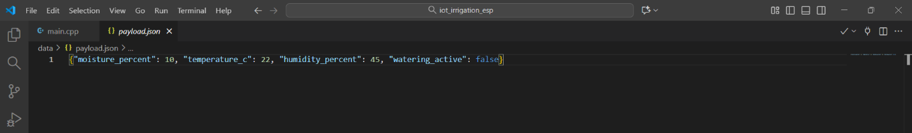
Figure 46: Payload JSON file Used for Attack Injection (Threat 4)
- Preparation of file containing malicious payload.
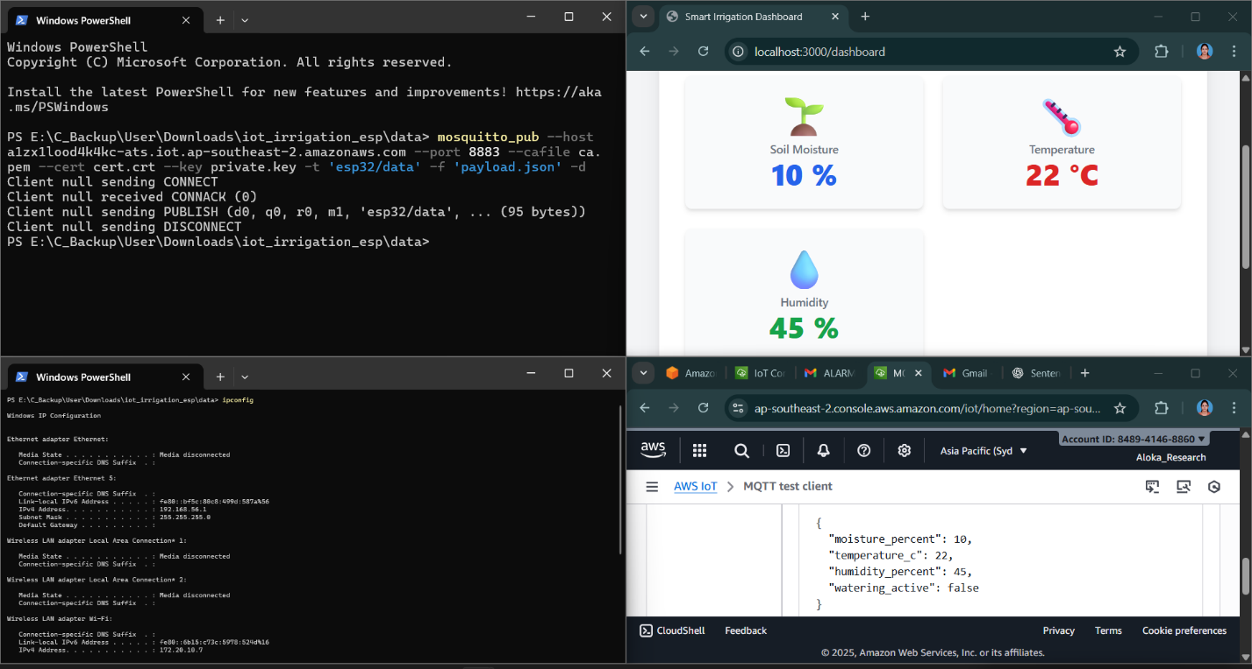
Figure 47: Device Credential Theft and Impersonation Attack Simulation - Before Security Implementation (Threat 4)
- Shows attack simulation with stolen credentials and untrusted IP.
Figure 48: IP Lookup - Attacker
- Confirms attacker is using a different public network.
Figure 49: Sensor Data Injection Simulation - Before Security "Out of Range" Payload Accepted by Cloud & Displayed on Dashboard (Threat 2)
- The dashboard displays spoofed values as if they are genuine.
- Result: Whether the attack is a direct injection or impersonation, DynamoDB accepts and stores the bad data, polluting decision automation and historical trends.

After Mitigation (Layered Cloud Rules Enforced)
The multi-layered SaveSensorDataToDynamoDB rule now acts as a robust final filter:
sql
SELECT *, timestamp() as timestamp, parse_time("yyyy-MM-dd HH:mm:ss", timestamp(), "Pacific/Auckland") as readable_time, 'esp32' as deviceId
FROM 'esp32/data'
WHERE
-- Layer 1: Data Payload Validation (Mitigates Threat 2)
moisture_percent >= 10 AND moisture_percent <= 90
AND temperature_c >= 0 AND temperature_c <= 40
AND humidity_percent >= 30 AND humidity_percent <= 90

-- Layer 2: Source IP Validation (Mitigates Threat 4)
AND sourceip() = '60.234.105.55'

-- Layer 3: Device State Validation (Mitigates Quarantined Devices)
AND (isundefined(get_thing_shadow(clientId(), 'arn:aws:iam::848941468860:role/IoTRuleGetShadowRole').state.reported.quarantined)
OR get_thing_shadow(clientId(), 'arn:aws:iam::848941468860:role/IoTRuleGetShadowRole').state.reported.quarantined = false)
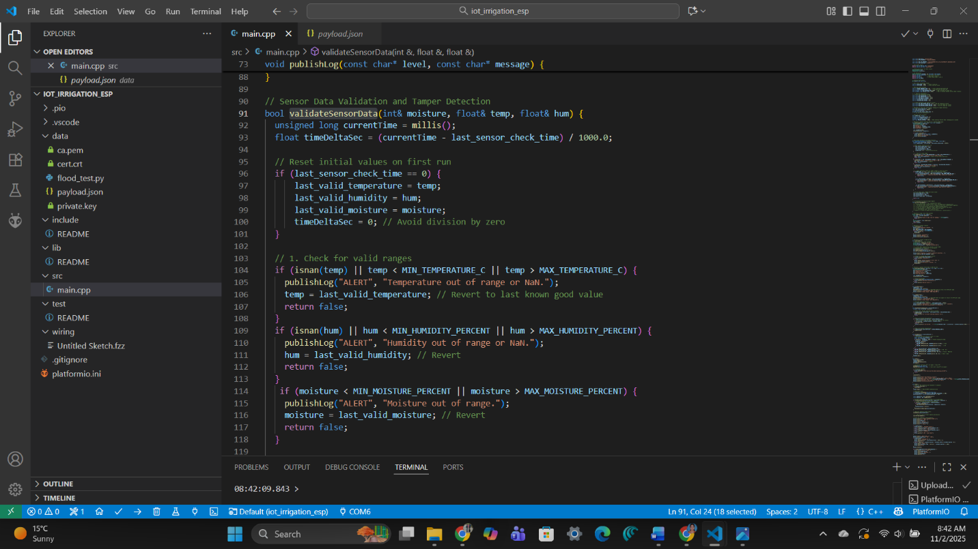
Figure 50: Sensor Data Validation ESP - Part 1
- Documents the local ESP firmware’s range validation, showing defense begins at the edge.
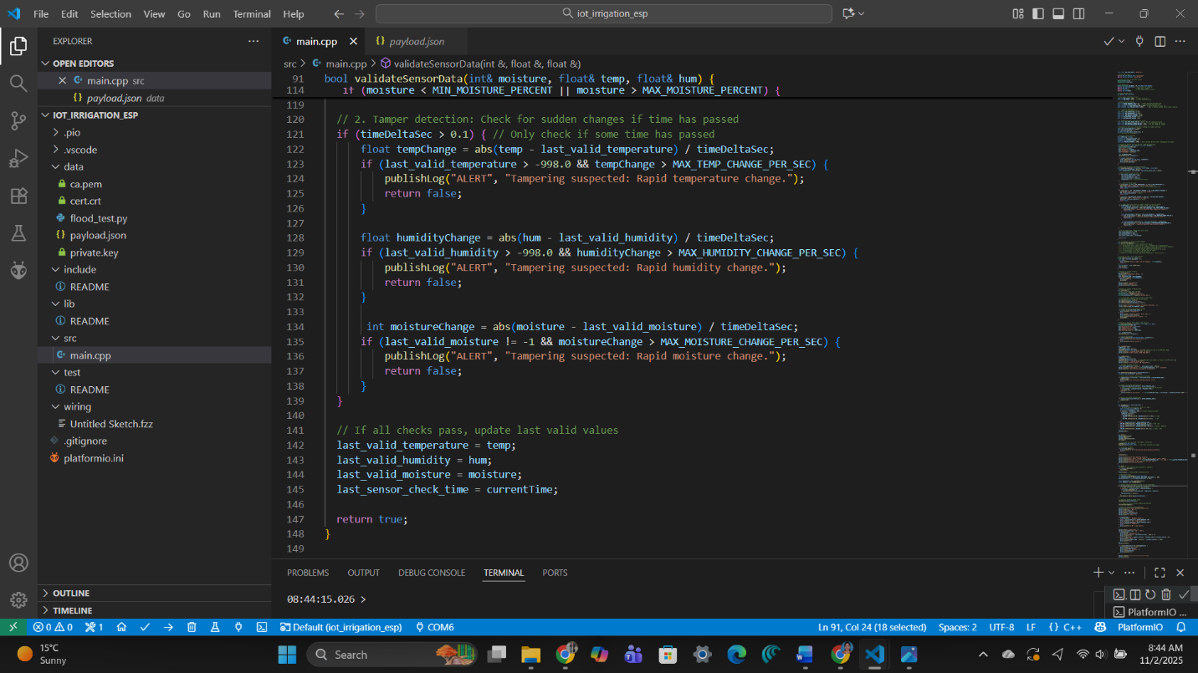
Figure 51: Sensor Data Validation - Part 2
- Explains how edge logic is complemented by cloud logic for dual-layer protection.
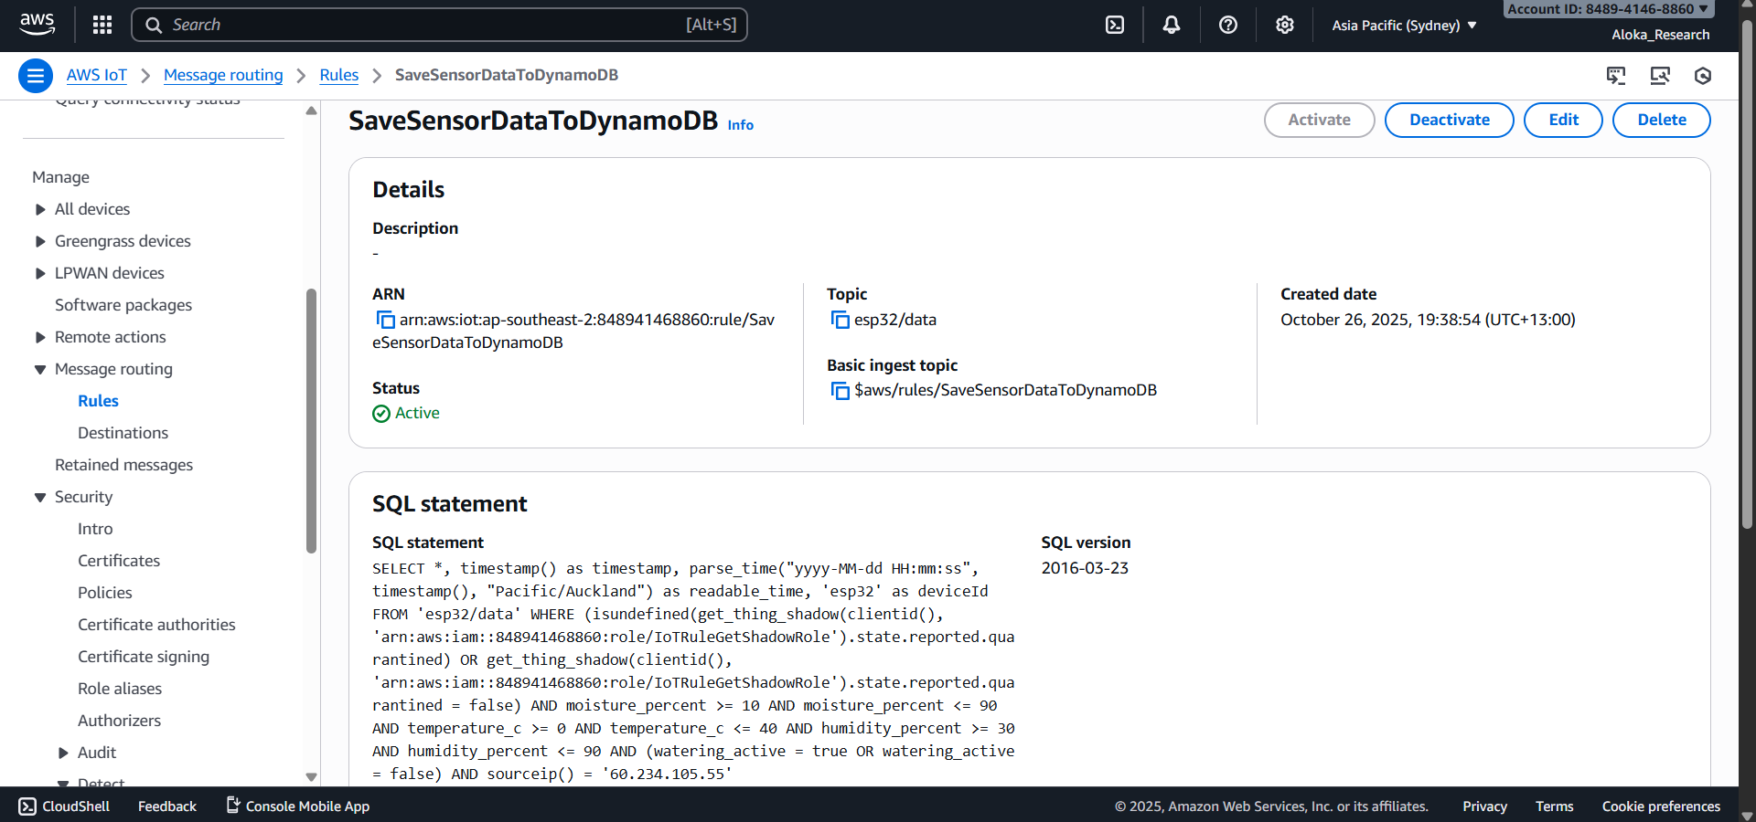
Figure 52: Consolidated AWS IoT Rule - SaveSensorDataToDynamoDB with Layered Validation Logic
- A full view of the three-layer SQL logic in the AWS rule engine.
Figure 53: AWS IoT CloudWatch Alarm triggered for Data Injection Attempt (Threat 2)
- Real-time CloudWatch detects and alarms on any data injection attempt.
Figure 54: CloudWatch Log of Blocked Injection Event (Threat 2)
- Forensic log of the blocked malicious data, ensuring post-breach auditability.
Figure 55: Email notification of High Severity Data Injection Attempt (Threat 2)
- Email notification ensures real-time operator response.
Figure 56: SNS Alert Email for Message Flood Quarantine Events (Threat 3)
- SNS/email alerts also serve for related (DoS/flood) integrity risks.
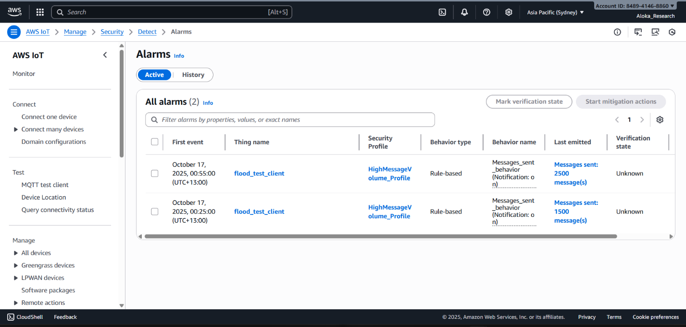
Figure 57: AWS IoT Device Defender alarm triggered under MQTT Flood attack conditions (Threat 3)
- Device Defender alarm supplements detection capabilities.
Figure 58: Lamda Auto Quarantine Log CloudWatch Device Quarantined After Flood Detection (Threat 3)
- Logs quarantine actions, documenting automated remedial controls.
Figure 59: AWS IoT Device Defender Alarm Dashboard (Threat 4)
- The IoT Defender dashboard displays real-time alarm status linked to source/IP violations.
Figure 60: AWS SNS Email notification of IP Violation (Threat 4)
- Instant email notification of unauthorized IP activity or rule violation.
Behavior: Any malicious input—wrong range, unexpected IP, or from a quarantined device—is blocked by the WHERE clause. Only data that fully matches every integrity and trust constraint is saved, securing both historic and live system records.

Detection and Mitigation Mapping
Prototype Control | MITRE ATT&CK Mitigation ID | Mitigation Name | Function in Prototype
Layered payload/IP/device state validation in One Cloud Rule | M0818 (ICS), M1047 (Ent.) | Validate Program Inputs, Audit | Prevents all forms of malicious data recording
Centralized CloudWatch/SNS anomaly logging and alerting | M1047, M1069 | Audit, Monitor/Alert | Provides operator visibility and response
End-to-end device <-> cloud defense in depth | M0800, M1036 | Authorization Enforcement, Key Management | Protects against credential abuse

Residual Risk and Improvements
- Risk: Stealthy attackers blend within thresholds, or compromise multiple layers.
- Recommendation: Enable continuous behavior analytics, rotate keys, and enforce defense-in-depth at ALL system layers.
Protecting the core database from manipulated or externally-injected data is fundamental in modern IoT research and practice. This scenario synthesizes the necessity for layered validation to ensure reliability, public trust, and operational resilience in automated agriculture systems.
Multi-layered data validation at the cloud entry point, paired with exceptional log and alarm coverage, ensures System-of-Record integrity for agricultural IoT deployments. No false or adversary-originated data enters the trusted store, empowering robust and accurate analytics, control, and traceability.

User Layer — Threat 7: User Authentication Brute-Force Attack
Overview and Context
A brute-force authentication attack targets the user account layer by systematically guessing passwords until the correct one is found. In a typical web application, lack of protective mechanisms can lead to unauthorized access and subsequent data breaches, especially if weak or reused passwords are present. Such attacks pose immediate risk of account takeover and are a stepping-stone to more devastating compromises across device and cloud layers.
MITRE ATT&CK Mapping
MITRE Domain | Tactic | Technique | Technique ID
Enterprise | Credential Access | Brute Force | T1110
This precisely matches ATT&CK’s Brute Force (T1110) pattern: automated attempts to discover passwords or keys via repeated trial.​
CVSS v3.1 Assessment
Metric | Value | Rationale
AV | N | Remote, over the internet
AC | L | Easily scripted, simple logic
PR | N | No prior access required, targets public login surface
UI | N | No user interaction needed
S | U | Attack impacts user account and, upon success, whole system trust
C | H | High—attacker can access or synthesize user data
I | L | May modify some user records or trigger user-side actions
A | H | Can lock out legitimate users, disrupt access, or escalate further attacks
Base Score: 7.5 (High)
How to Emulate
- The attacker tries to log in to the Smart Irrigation Dashboard multiple times, cycling through different passwords for valid or guessed usernames.
- They monitor application and console responses after each attempt to detect if any rate limiting or blocking is enforced.

Before (No Brute-Force Protection)
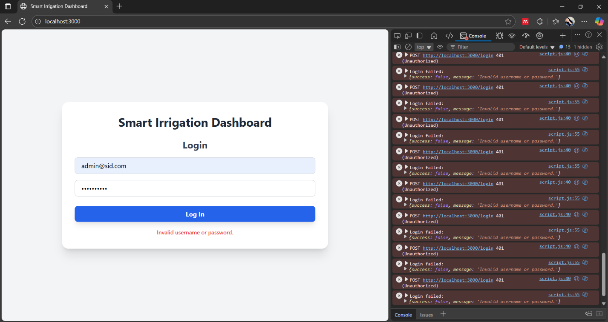
Figure 61: Failed login attempts - Incorrect Password
- The attacker enters a valid username with an incorrect password. The login form and browser console display repeated login failures, but the system allows unlimited retries with no lockout or notification.
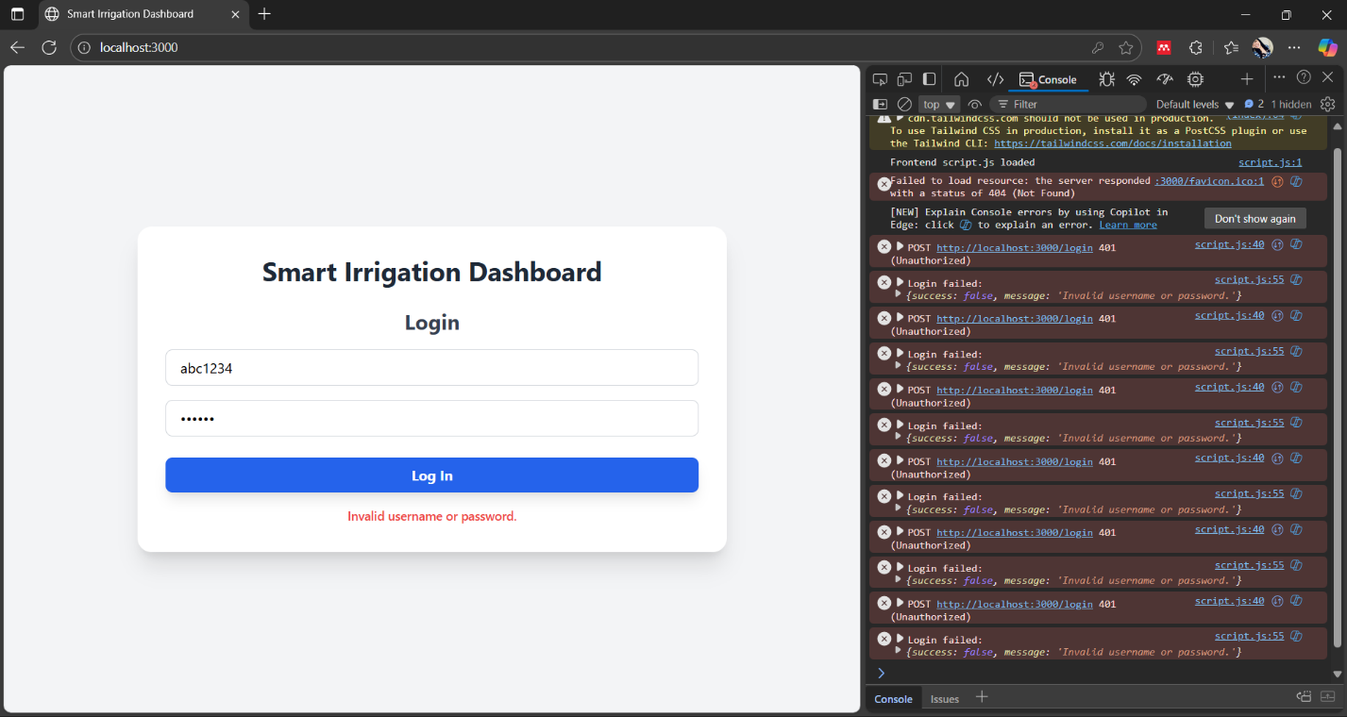
Figure 62: Failed login attempts: Incorrect username
- Similar results when fake or mistyped usernames are used—again, no detection or limit.
- Behavior: The backend does not log or act upon the repeated failures. This unbounded feedback allows automated brute-force scripts to try potentially thousands of passwords, relying solely on password strength for defense.
After (Cognito Advanced Security & Lambda Triggers)
A multi-layered protection approach is deployed:
- Cognito Advanced Security: AWS Cognito’s out-of-the-box anomaly detection identifies login flooding and unusual patterns, possibly blocking risky sessions automatically.
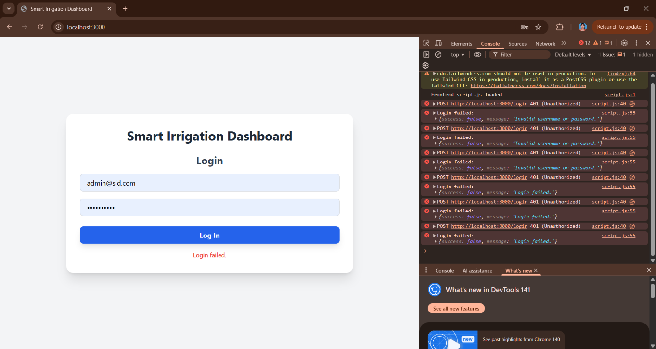
Figure 63: Client login attempts blocked by Cognito client console
  - Shows login interface and developer console with automated blocking messages after repeated attempts.
- Lambda Triggers with Stateful Lockout:
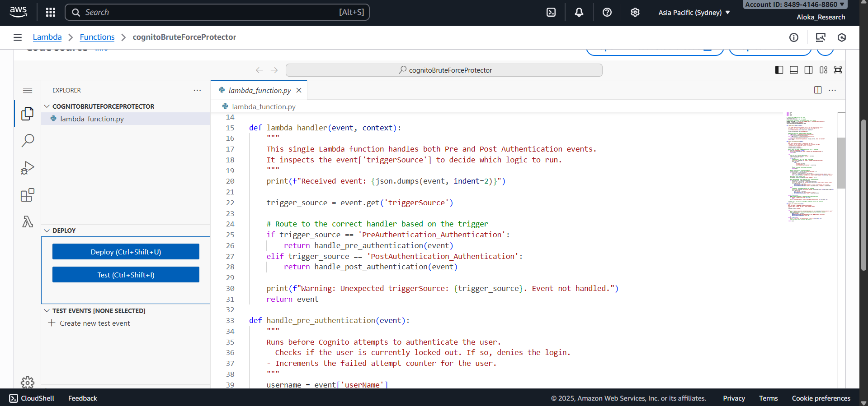
Figure 64: Lambda function Prepost Authentication for Brute Force Protection
  - The Lambda function connects to the Cognito authentication flow and DynamoDB.
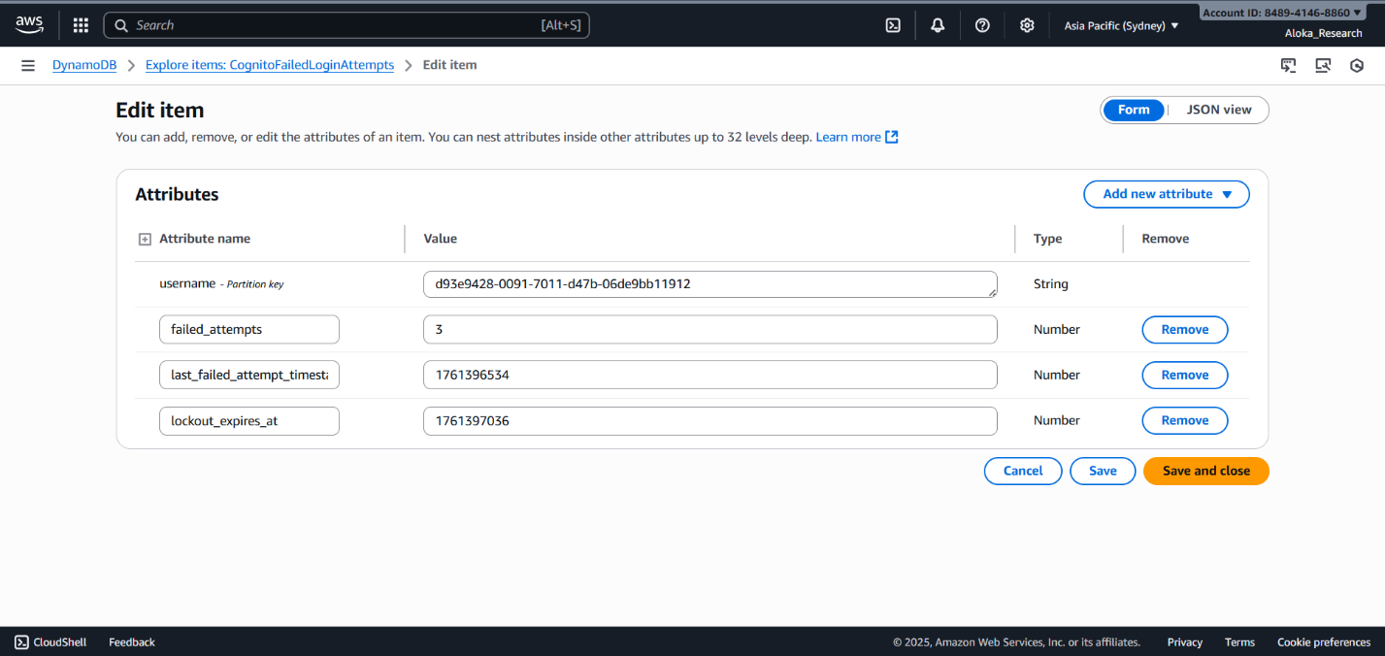
Figure 65: Dynamo DB record for failrf loging tracking lockout
  - Each login try updates counters and timestamps in DynamoDB’s CognitoFailedLoginAttempts table—tracking failed attempts in real time.
How It Works:
  - PreAuthentication Lambda fires before password matching, querying DynamoDB for failed attempts:
    - If the user is currently locked out, the function blocks the login and notifies them immediately.
    - For non-locked users, a failed attempt increments their counter. Exceeding a set threshold (e.g., 3 attempts) sets a lockout expiry timestamp.
  - PostAuthentication Lambda runs after a correct password:
    - Resets the failure counter and clears lockouts, returning system to a clean slate.
  - The security and lockout logic runs regardless of automation or manual attempts, stopping both bots and humans.

Detection and Mitigation Mapping
Prototype Control | MITRE ATT&CK Mitigation ID | Mitigation Name | Function in Prototype
Rate limiting/account lockout (Lambda + DynamoDB) | M1027 | Password Policies/Lockout | Prevents brute-force by limiting/logging attempts
Automated anomaly/blocking (Cognito Security) | M1036 | Risk-Based Authentication | Detects/block repeated failures, risk flagging
Real-time alerting for lockouts | M1047 | Audit | Can trigger admin notification and further review

Residual Risk and Improvements
- Risk: Distributed attacks mutate sources/IPs to spread attempts. Weak secret questions or password-reset may also be abused.
- Improvements: Implement multi-factor authentication (MFA), integrate CAPTCHA, and routinely audit credential recovery flows.
Credential bruteforcing remains a top vector in user-facing smart applications. Its mitigation—via layered lockouts, anomaly tracking, and stateless resets—is necessary for real-world, production-grade IoT user authentication resilience.
Effective defense against web authentication brute-force requires pairing advanced security and adaptive rate monitoring (Cognito) with stateful Lambda logic for account lockout and healing. Together, these measures prevent both massed and targeted attacks, keeping user identities and system entrypoints secure.
User Layer — Threat 8: Session Hijacking or Token Theft
Overview and Context
Session hijacking via token theft is a critical security threat for web-based IoT user interfaces. When authentication tokens are stored in browser localStorage, they become vulnerable to extraction by malicious scripts (Cross-Site Scripting) or browser extensions. If an attacker copies these tokens, they can impersonate the legitimate user for as long as the token remains valid, gaining unrestricted access to sensitive controls and data.
MITRE ATT&CK Mapping
MITRE Domain | Tactic | Technique | Technique ID
Enterprise | Credential Access | Steal Web Session Cookie | T1539
This matches ATT&CK's "Steal Web Session Cookie" (T1539), where attackers extract session tokens from browser storage or memory to hijack user sessions.
CVSS v3.1 Assessment
Metric | Value | Rationale
AV | N | Token theft executable remotely via XSS or network interception
AC | L | Common attack vector, easily scripted
PR | N | Does not require prior authentication; token is obtained, not credentials
UI | R | May require user to visit malicious site or be already logged in
S | U | Impacts session and user context
C | H | Complete access to user's dashboard and data visibility
I | H | Can modify data, settings, trigger actions with user authority
A | L | Limited direct availability impact unless attacker disrupts services
Base Score: 7.9 (High)

How to Emulate
- Log into the Smart Irrigation Dashboard via a browser.
- Open browser Developer Tools (F12) → Navigate to Application/Storage → Local Storage.
- Locate and copy the IdToken value.
- Open an incognito/separate browser window.
- Attempt to use the stolen token in an authenticated request (e.g., setting the Authorization header in a fetch request via the console).
While the Threat 7 - brute-force protections may collectively frustrate reuse, the exposure of tokens in localStorage remains a fundamental vulnerability.
Before (Insecure Session Management)
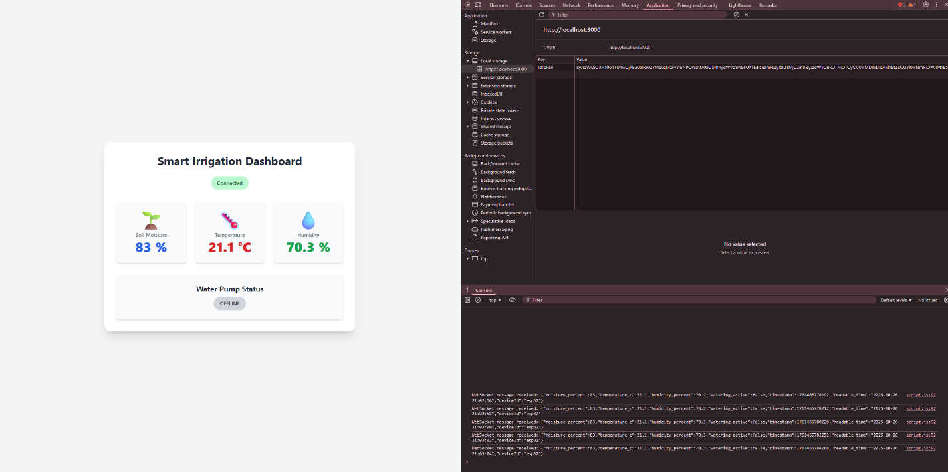
Figure 66: Web Dashboard session token exposure
- The browser's Application tab shows IdToken fully visible in localStorage, accessible to any script running in the same origin.
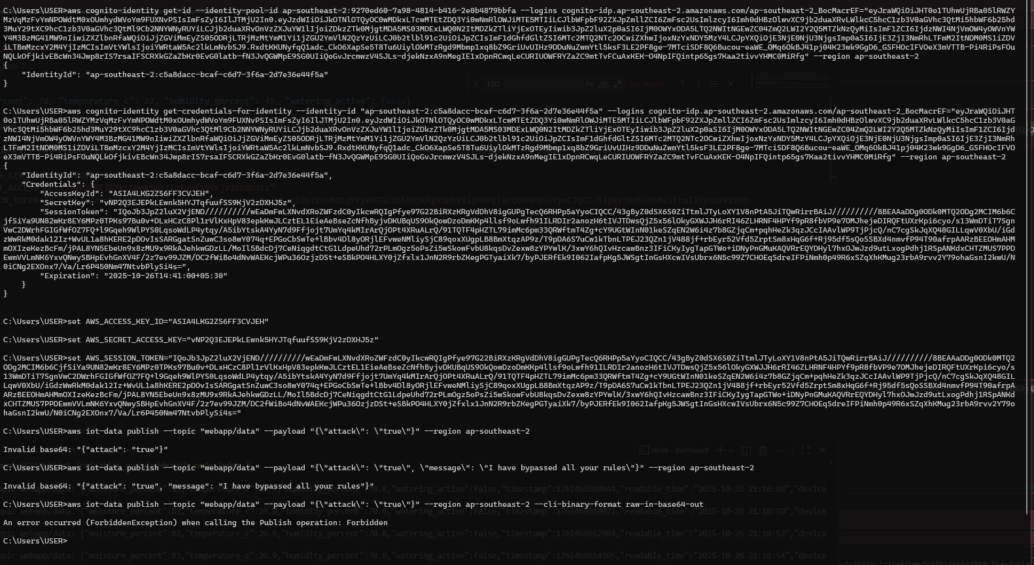
Figure 67: CLI Token-based attack attempt after token theft
- The attacker uses AWS CLI with the stolen credentials/token to execute an unauthorized publish command to the IoT endpoint, demonstrating full access reuse.
Behavior:
Cognito's default long-lived tokens (1-hour access, 30-day refresh) sit exposed in localStorage. An XSS attack or malicious browser extension can trivially extract them. Even after the user closes the browser tab, the token persists and remains valid until natural expiration. No server-side mechanism exists to revoke or invalidate the session preemptively.

After (Secure Session Management with Backend-for-Frontend)
The vulnerability is fundamentally remediated through architectural re-design into a Backend-for-Frontend (BFF) model. This moves token handling entirely to the server-side, shielding them from the browser.
1. Secure, Server-Managed Sessions (HttpOnly Cookies):
The Node.js backend server now:
- Receives IdToken and AccessToken from Cognito after successful login.
- Does NOT forward tokens to the client. Instead, it sets them in secure, HttpOnly cookies:
javascript
// In dashboard/index.js
res.cookie('IdToken', authData.AuthenticationResult.IdToken, {
httpOnly: true,
secure: process.env.NODE_ENV === 'production',
sameSite: 'strict'
});
- httpOnly: true: Prevents any client-side JavaScript from accessing the cookie—directly blocking XSS-based token theft.
- secure: true: Ensures cookies are only transmitted over HTTPS (in production).
- sameSite: 'strict': Protects against Cross-Site Request Forgery (CSRF) attacks.
2. Temporary Credential Brokering:
- Frontend No Longer Holds Long-Term Credentials: The browser client never receives AWS credentials or long-lived tokens.
- /api/credentials Endpoint: The server provides a secure endpoint that:
  - Validates the HttpOnly session cookie.
  - Brokers temporary, short-lived AWS credentials from Cognito Identity Pool specific to that user.
  - Returns only these ephemeral credentials to the client for MQTT WebSocket connection.
This adheres to the Principle of Least Privilege—clients only get the bare minimum required for their real-time data stream.

- Robust Server-Side Logout:
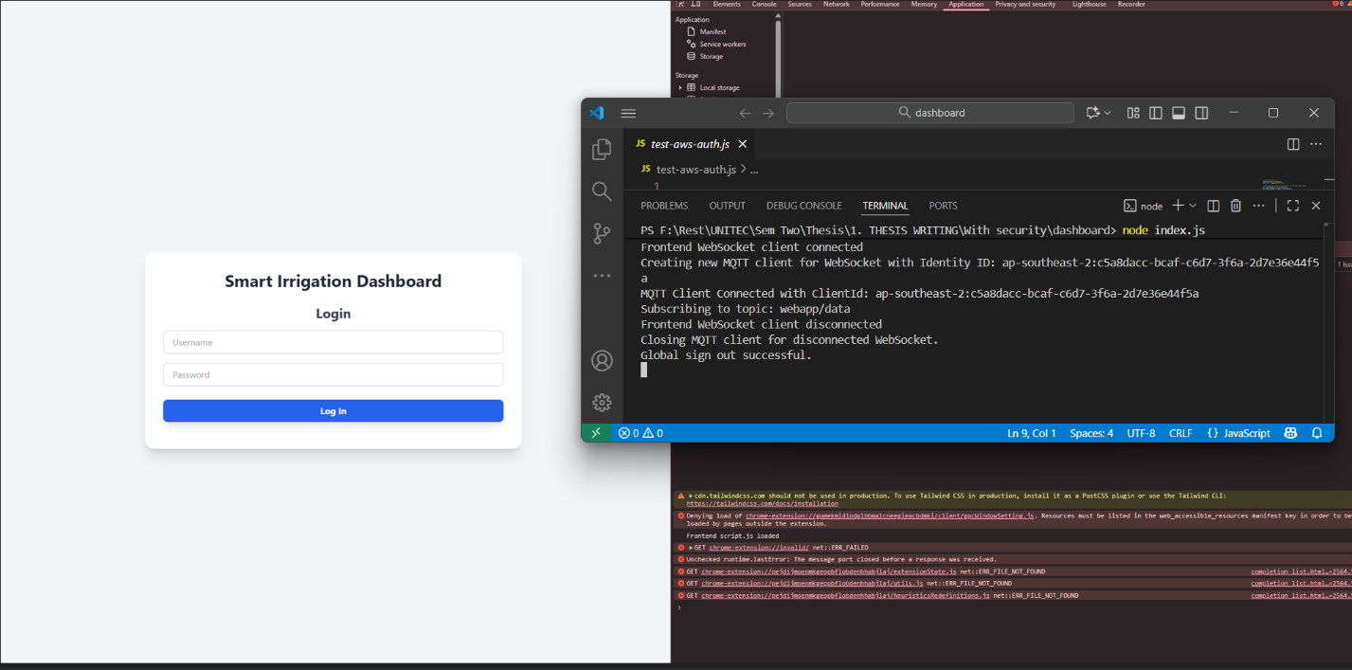
Figure 68: Global Signout
- The /logout endpoint on the server performs:
  - Cognito globalSignOut: Invalidates all refresh and access tokens server-side.
  - Cookie Clearing: Removes the HttpOnly session cookies from the browser.
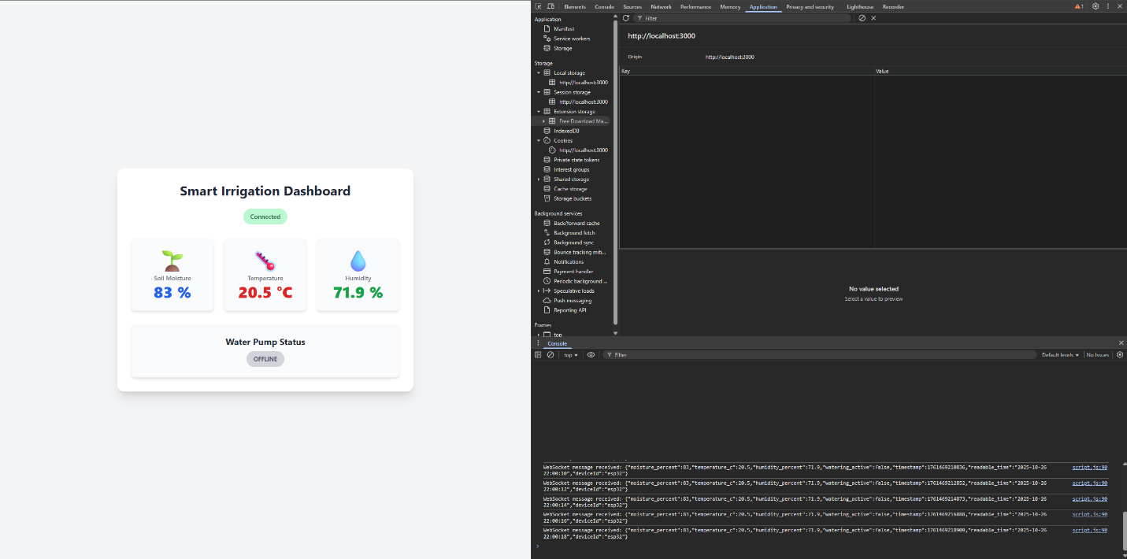
Figure 69: Tokens are not saved
- Shows the browser's Application tab after the secure implementation—no IdToken or sensitive tokens are visible in localStorage or any client-accessible storage.
Final Behavior (Prevention):
- No Token Theft via XSS: HttpOnly cookies are invisible to JavaScript, making XSS-based theft impossible.
- No Direct AWS Access: The frontend never holds long-lived credentials—only ephemeral, brokered tokens for limited MQTT access.
- Complete Session Invalidation: Server-side logout ensures tokens are revoked globally, preventing any post-logout reuse.
This defense-in-depth architecture shifts the security boundary from the inherently vulnerable browser to the controlled, trusted server environment.
Detection and Mitigation Mapping
Prototype Control | MITRE ATT&CK Mitigation ID | Mitigation Name | Function in Prototype
HttpOnly session cookies (BFF model) | M1054 | Software Configuration (Secure Flags) | Prevents client-side access to tokens
Temporary credential brokering | M1027 | Password/Credential Policies | Limits client exposure to long-lived secrets
Server-side global signout | M1026 | Privileged Account Management | Ensures complete revocation on logout

Residual Risk and Improvements
- Risk: XSS vulnerabilities in the application itself could still allow cookie theft if httpOnly is misconfigured or bypassed.
- Improvements: Implement Content Security Policy (CSP), regularly audit code for XSS flaws, deploy Sub-Resource Integrity (SRI), and consider multi-factor authentication.

Token theft and session hijacking are among the most prevalent and damaging web application threats. Modern security best practices uniformly advocate for server-side session management and HttpOnly cookies to protect user sessions from client-side attacks, especially in IoT contexts where compromised sessions can lead to physical system manipulation.
By transitioning from client-side localStorage to server-managed HttpOnly cookies in a Backend-for-Frontend architecture, the Smart Irrigation Dashboard completely eliminates the attack vector for token theft. Combined with temporary credential brokering and robust logout mechanisms, this design ensures user sessions remain secure against modern web-based attacks.

